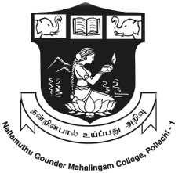

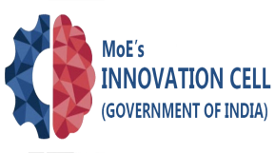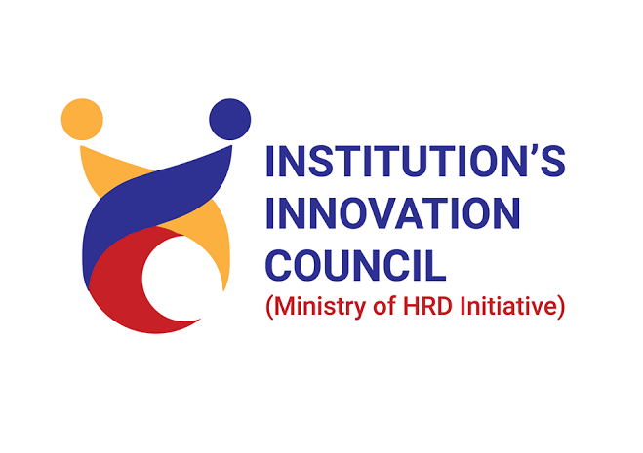
Nallamuthu Gounder Mahalingam College, Pollachi.
Department of Social Work and Institution’s Innovation Council (IIC)
Jointly organizes
Innovation Strategy for Entrepreneurship Development
Date: 24.02.2023
AGENDA

Prayer Song : TAMIL THAI VAAZTHU”

Welcome Address : Ms.Vignakala,
II MSW Student,
Department of Social Work,
N.G.M College, Pollachi.
Special Address : Mr.S.Vignesh Kumar, M.S.W.,M.A.,(Ph.D).,
Assistant Professor, Department of Social Work,
N.G.M College, Pollachi.

Presidential Address : Dr.R.Muthu Kumaran M.A.,M.Phil.,B.Ed.,Ph.D.,
Principal, N.G.M College, Pollachi.
Students Presentation
Prize Distribution
Vote of Thanks : Ms.Keerthana,
II MSW Student,
Department of Social Work,
NGM College, Pollachi.
National Anthem
“ALL ARE CORDINALLY INVITED

