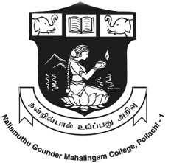

N.G.M. COLLEGE
(An Autonomous Institution, Affiliated to Bharathiar University)
Re-Accredited by NAAC, ISO 9001:2015 Certified Institution
Pollachi – 642 001

PG & RESEARCH DEPARTMENT OF SOCIAL WORK

EMPOWERING RURAL THROUGH SOCIAL WORK
PRACTICE

RURAL CAMP
(2021-2023)

DATE: 16.05.2022 to 21.05.2022
PLACE: GOLLAPATTI, POLLACHI

