Photographs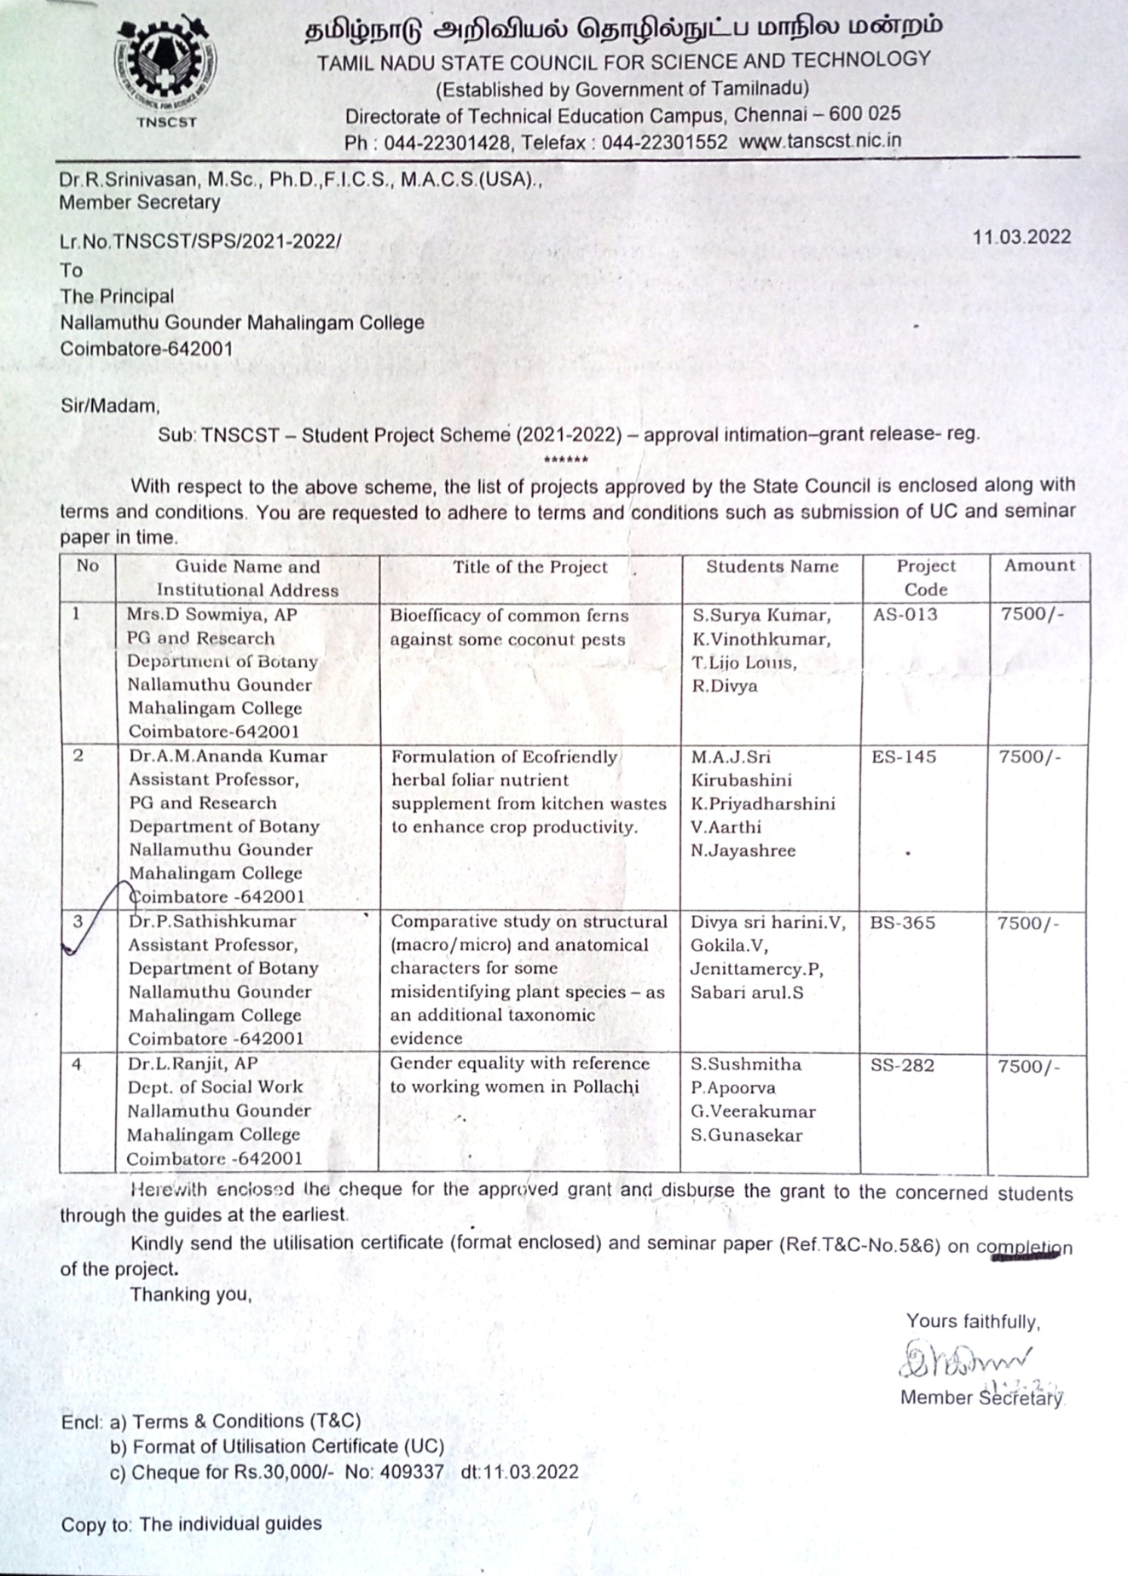

“In house workshop and hands on training in Plant Biotechnology” - 10th March 2016
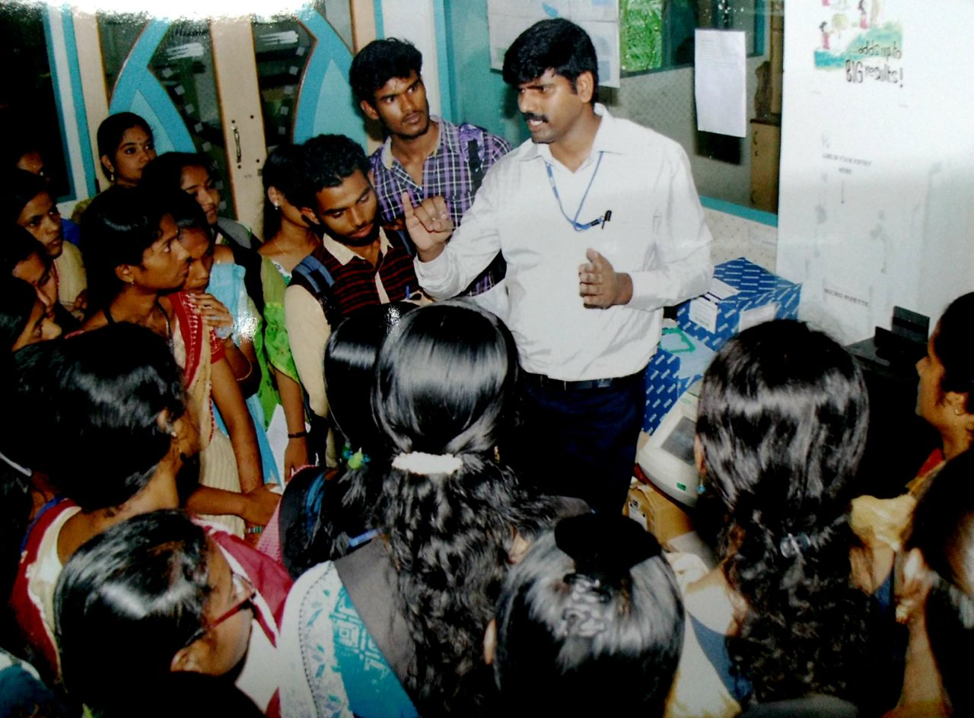
“SPSS- Applications in Biostatistics” on 4th October 2016.
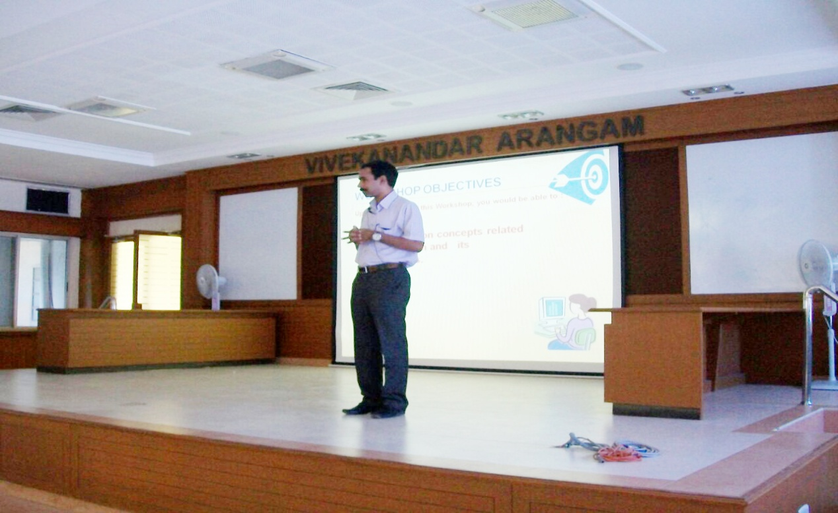
Training cum workshop on “Basic Techniques in Botany -15th March 2017
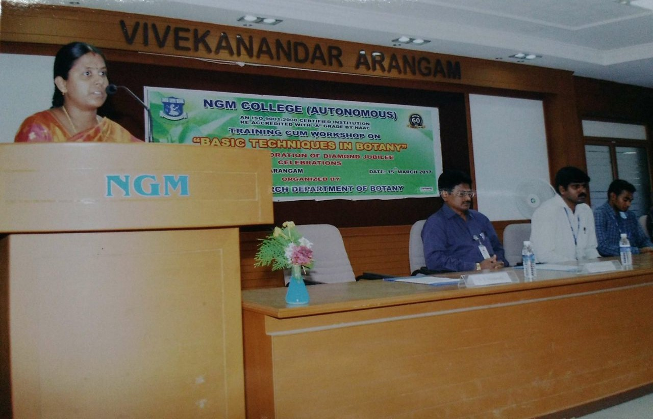

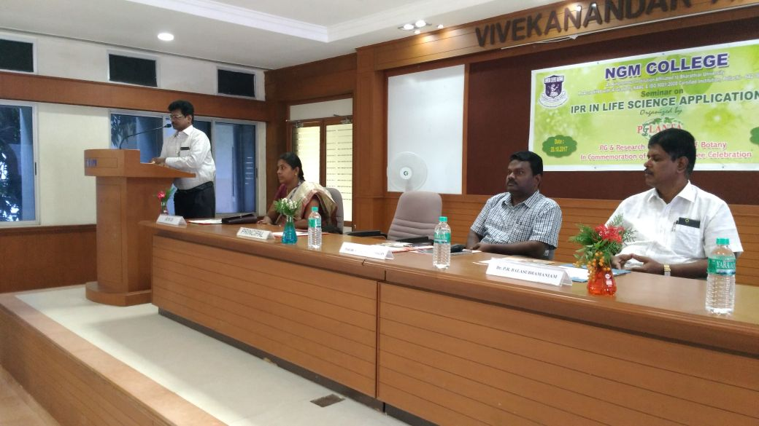
Seminar on IPR in Life Science Applications -20th October 2017

International Symposium on Composting and solid waste management - 16th November 2017
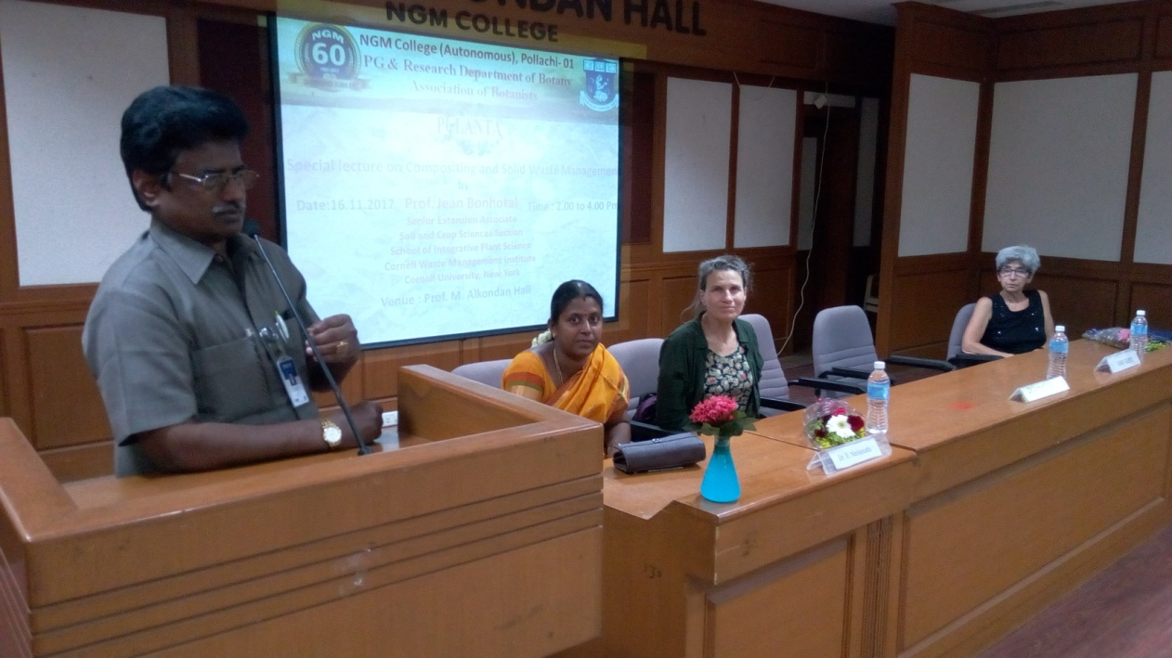

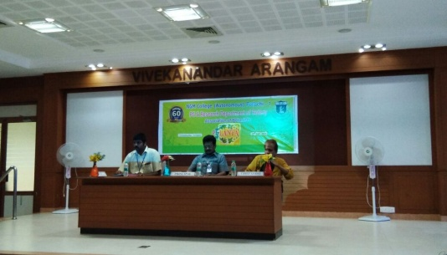
Inauguration the association of Botanist PG PLANTA with special lecture on “Relevance and importance of angiosperm taxonomy- 19th July 2017
MoU of NGM College, Pollachi and Vanavarayar Institute of Agriculture, Manakkadavu, Pollachi - 13th December 2017
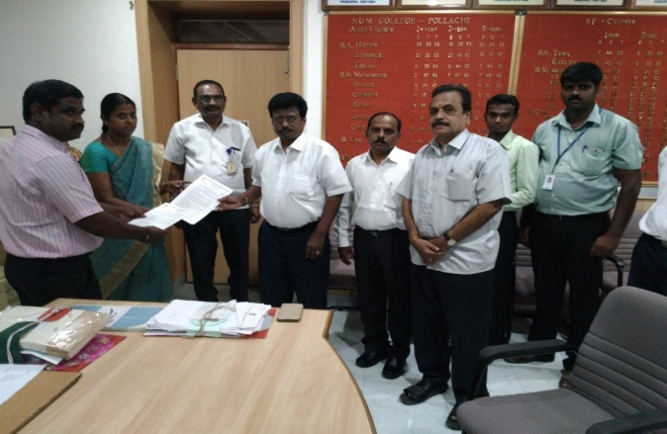

Workshop on Practical Botany - 24th January 2018
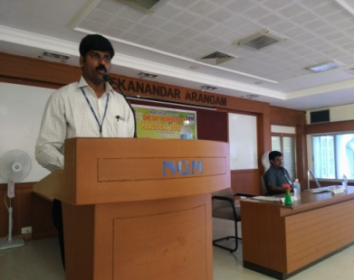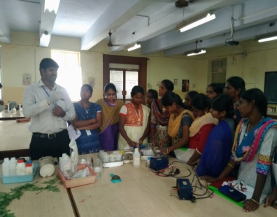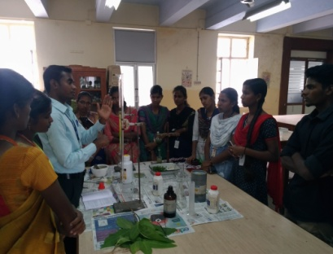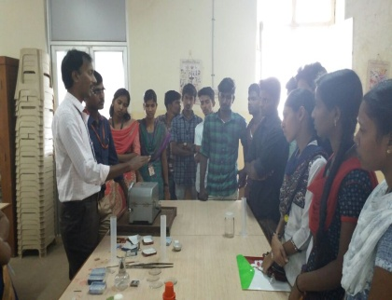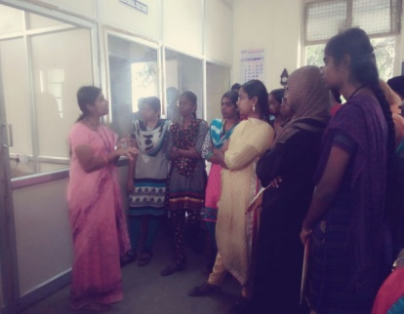

Two day Science Academies Lecture Workshop on “Linnaean to Digital Era of Plant Systematics” - 7th and 8th December 2017
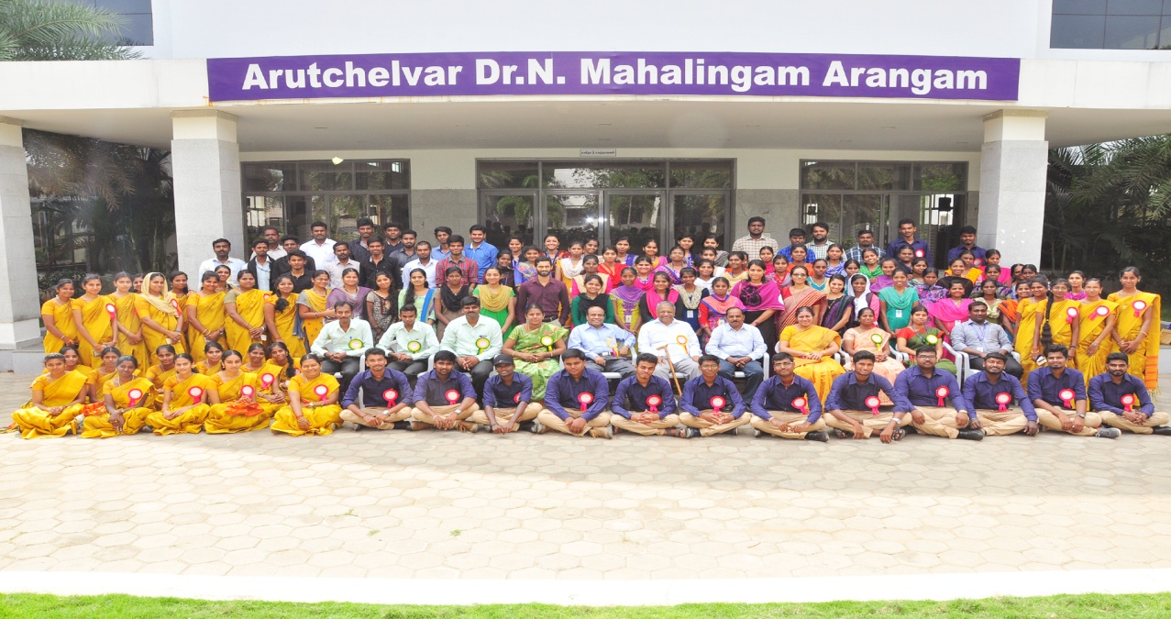
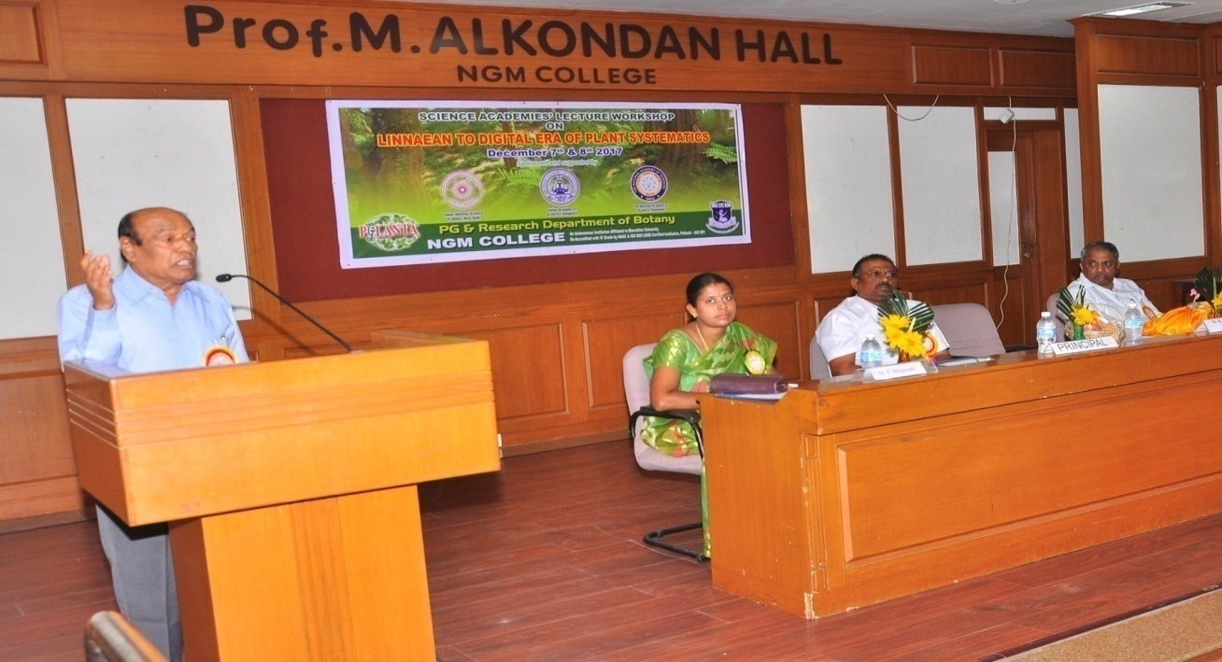
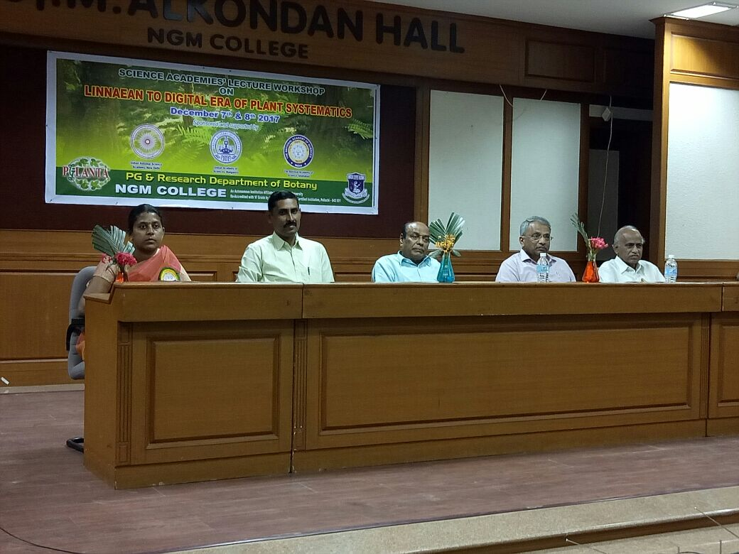
Association guest lecture -Current and future trends in Molecular Biology and Biotechnology- 20th August 2018.
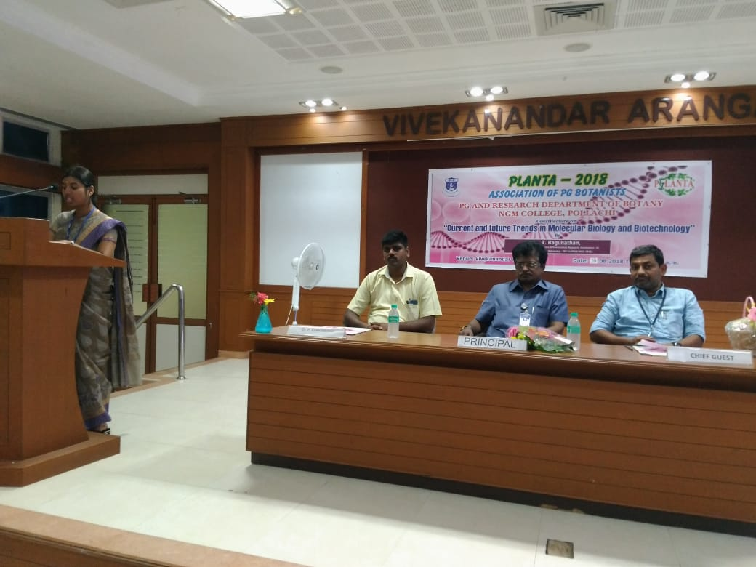
National level training - Workshop on Plant taxonomy - October 5th & 6th 2018
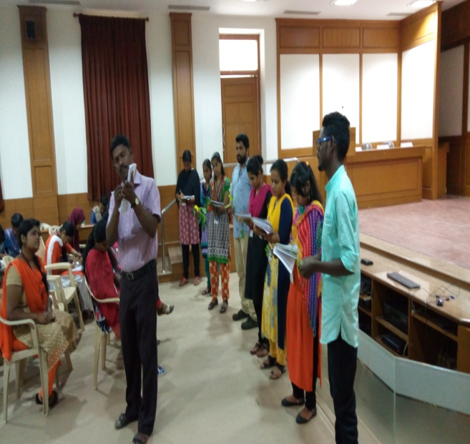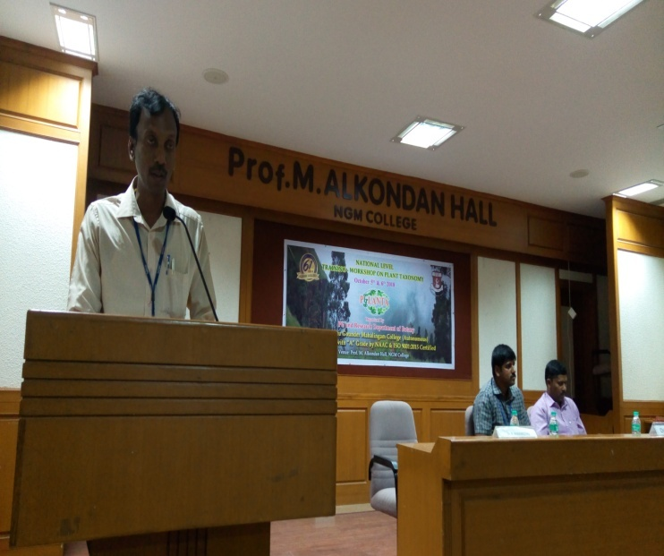

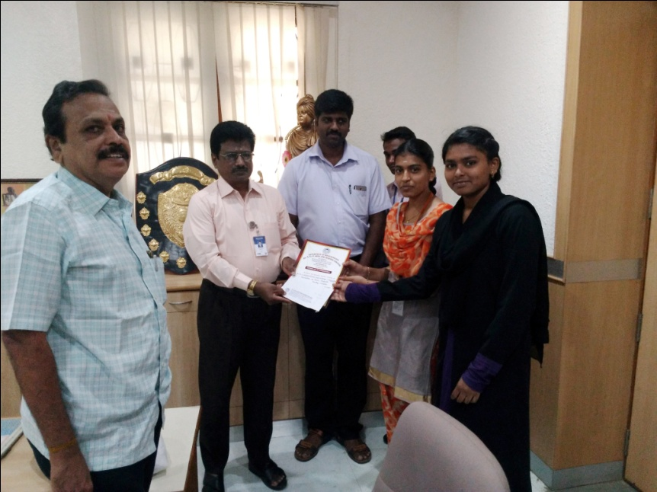
Students appreciated & awarded II prize in Bio Innovative ’18 - State Level Innovative Idea Contest

Workshop on Foldscope and its applications, - 5th February 2019.
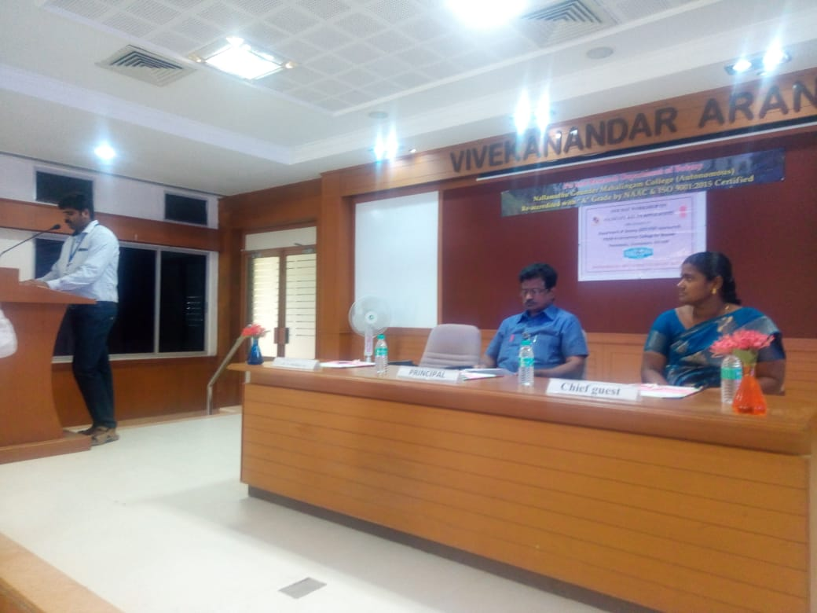

India for Tigers “Rally on wheels” in commemoration of 75th anniversary of Indian Independence – Azadi ka Amrit Mahotsav on 30.09.2021
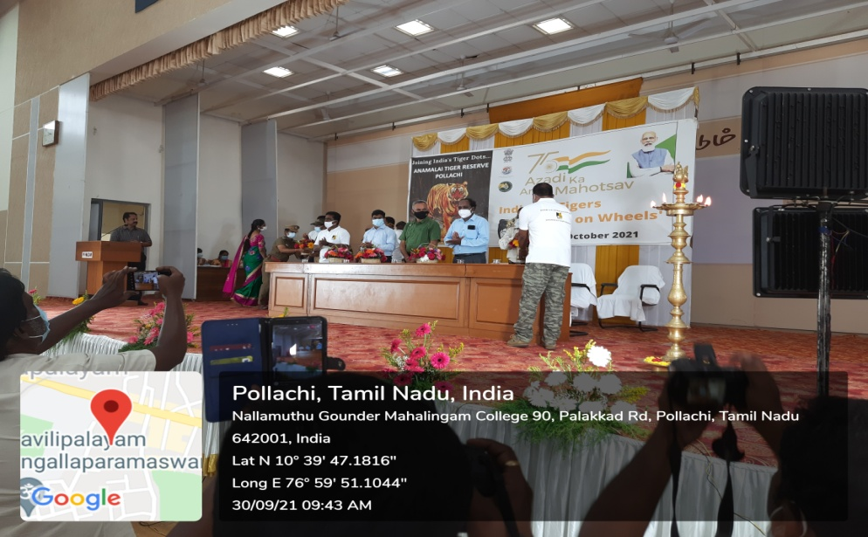
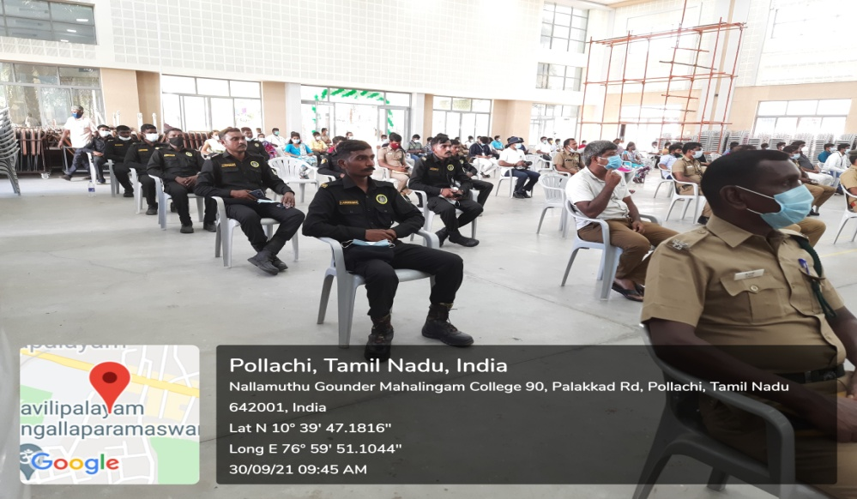
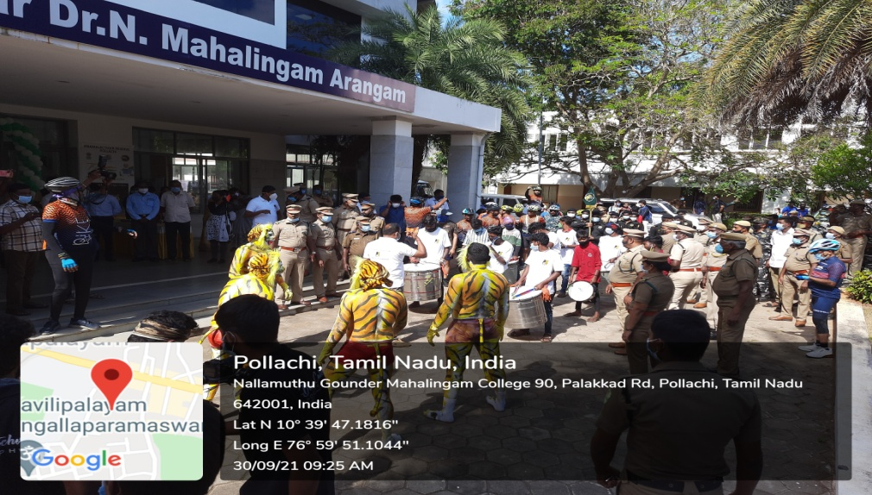
‘Tree plantation programme' In commemoration of “International Day for Biological Diversity' on 29.12.2021
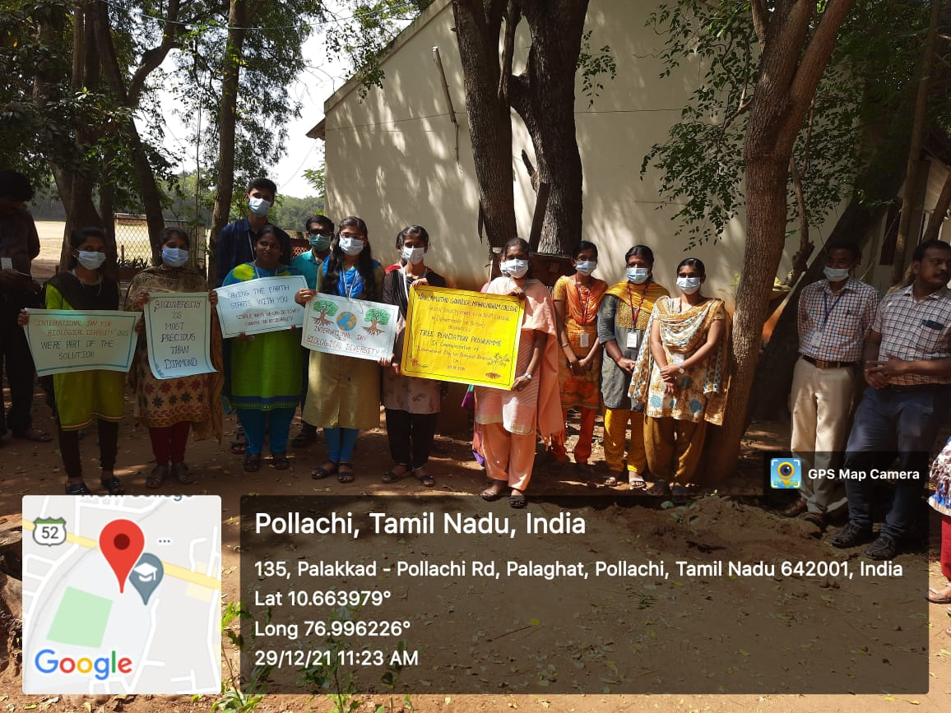
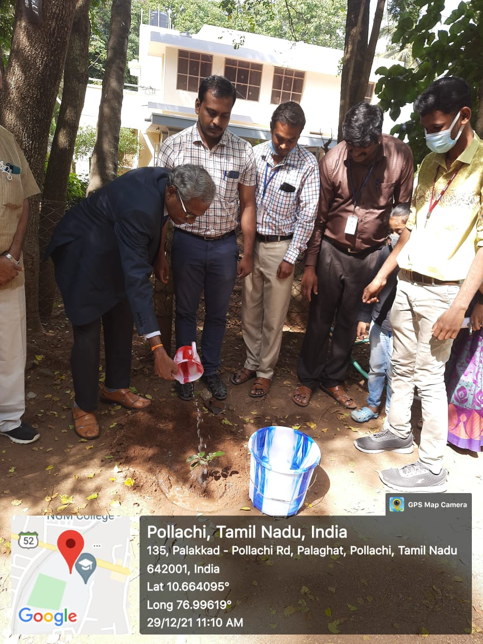
‘IPR in Life Sciences ‘on 21st April 2022 In commemoration of world IPR day
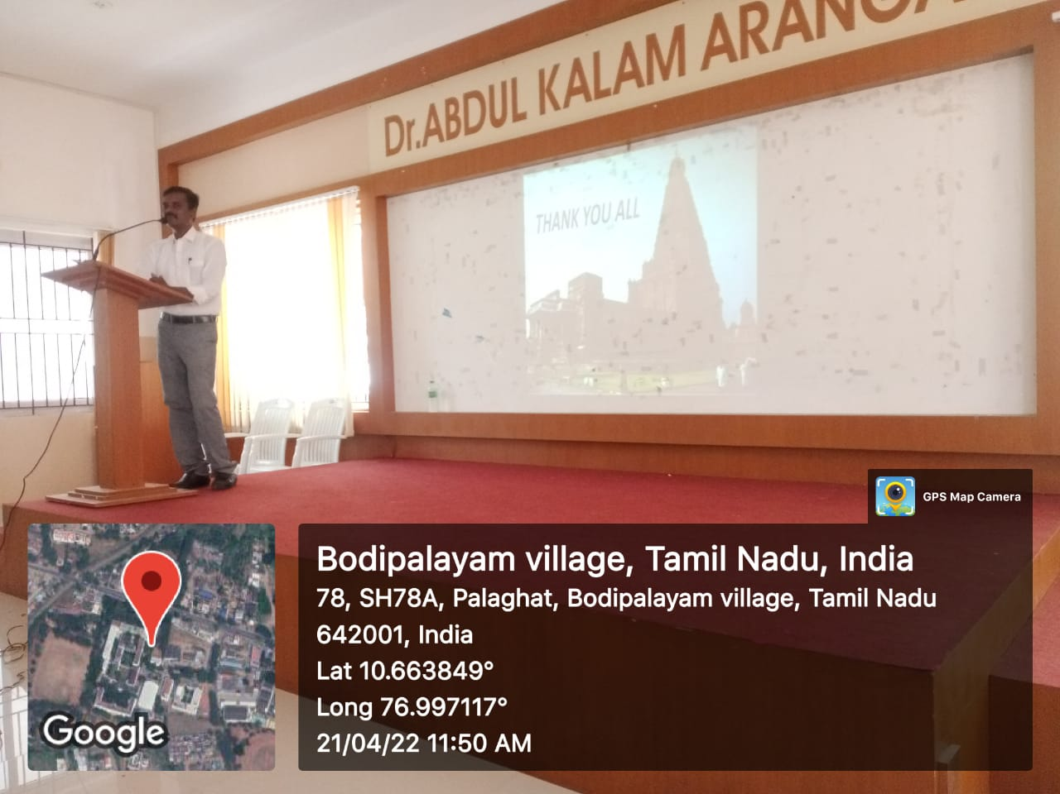
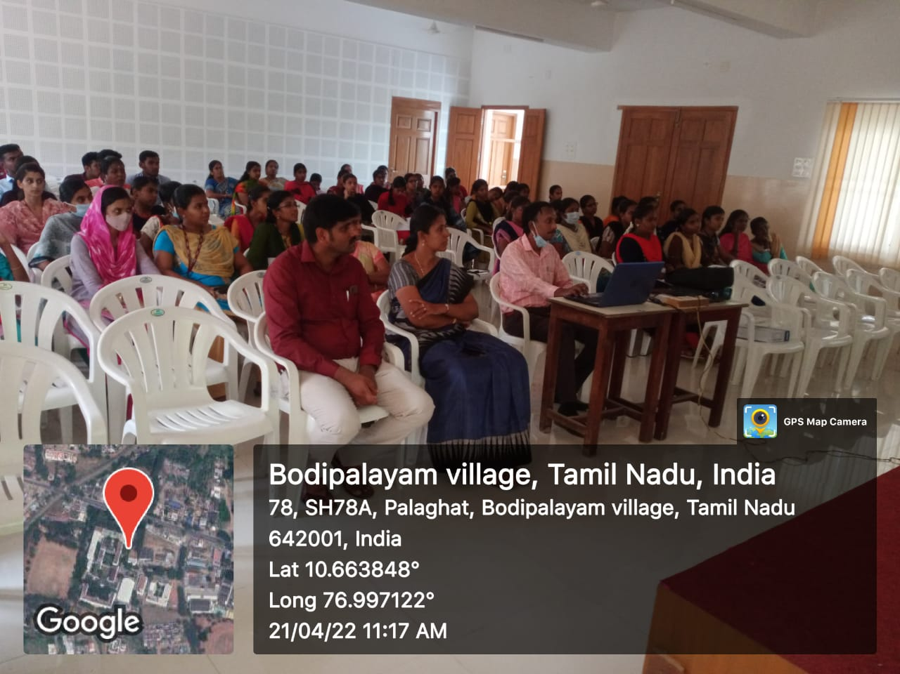
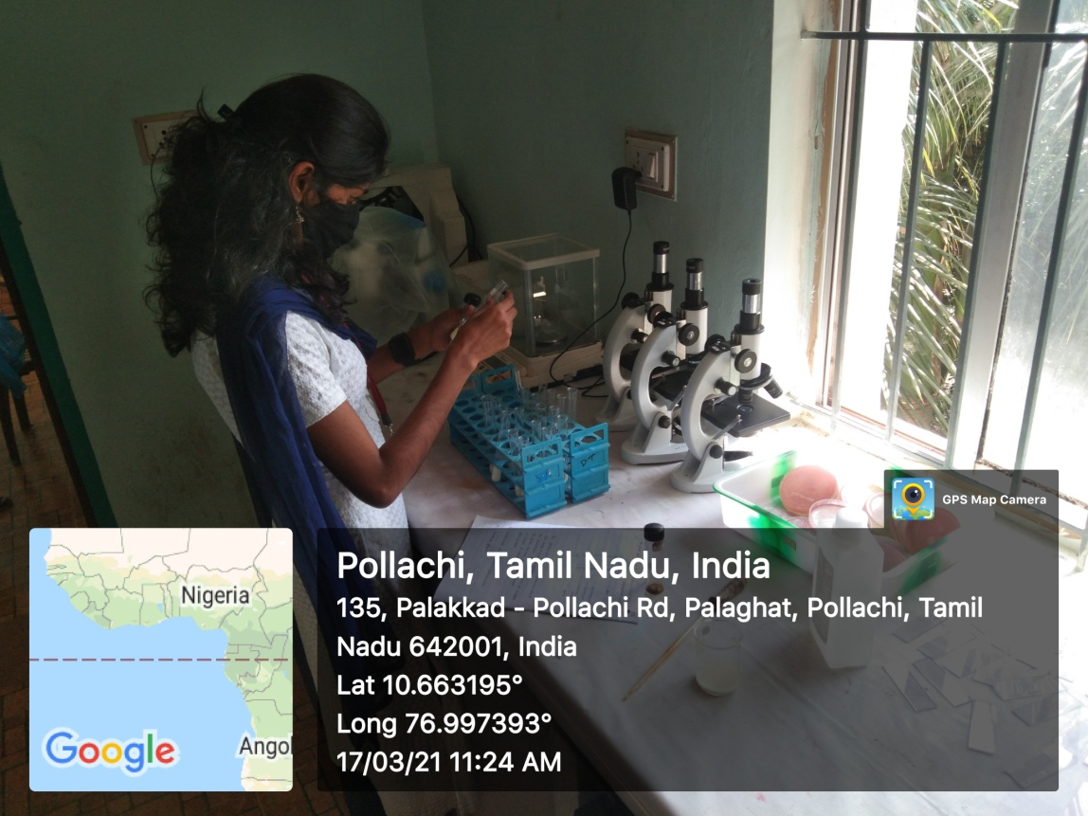
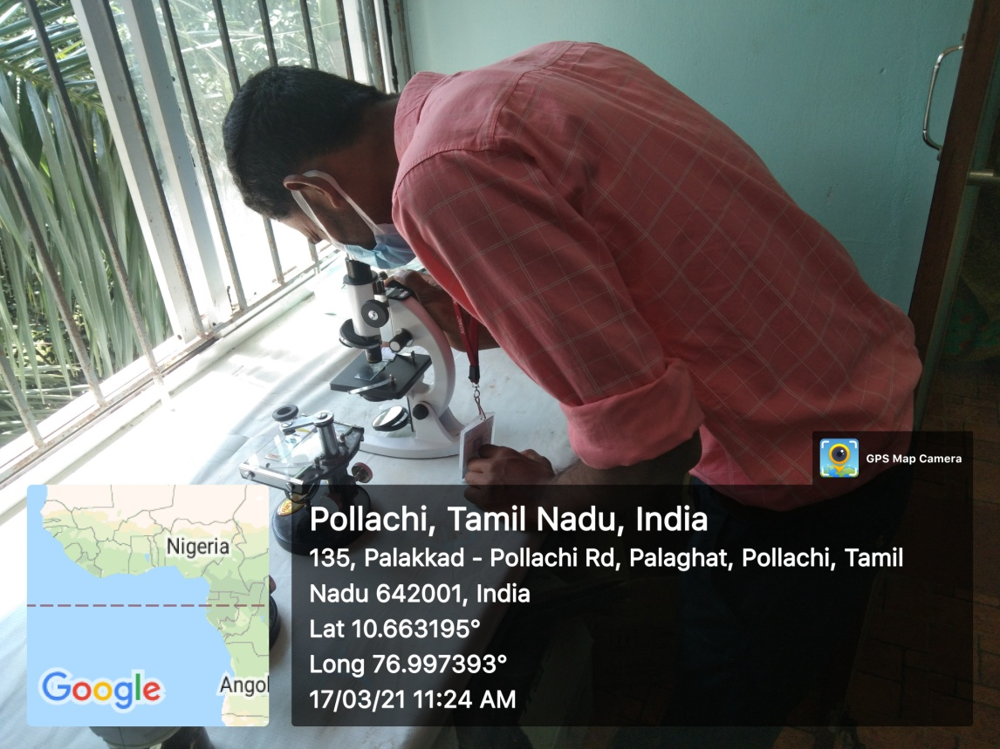
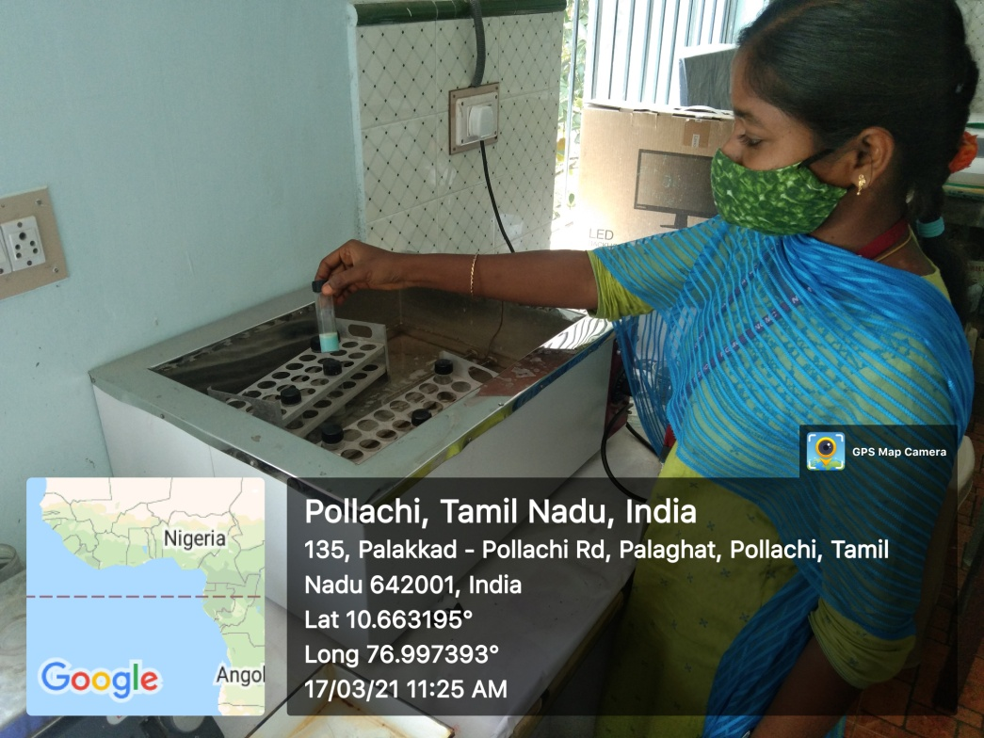
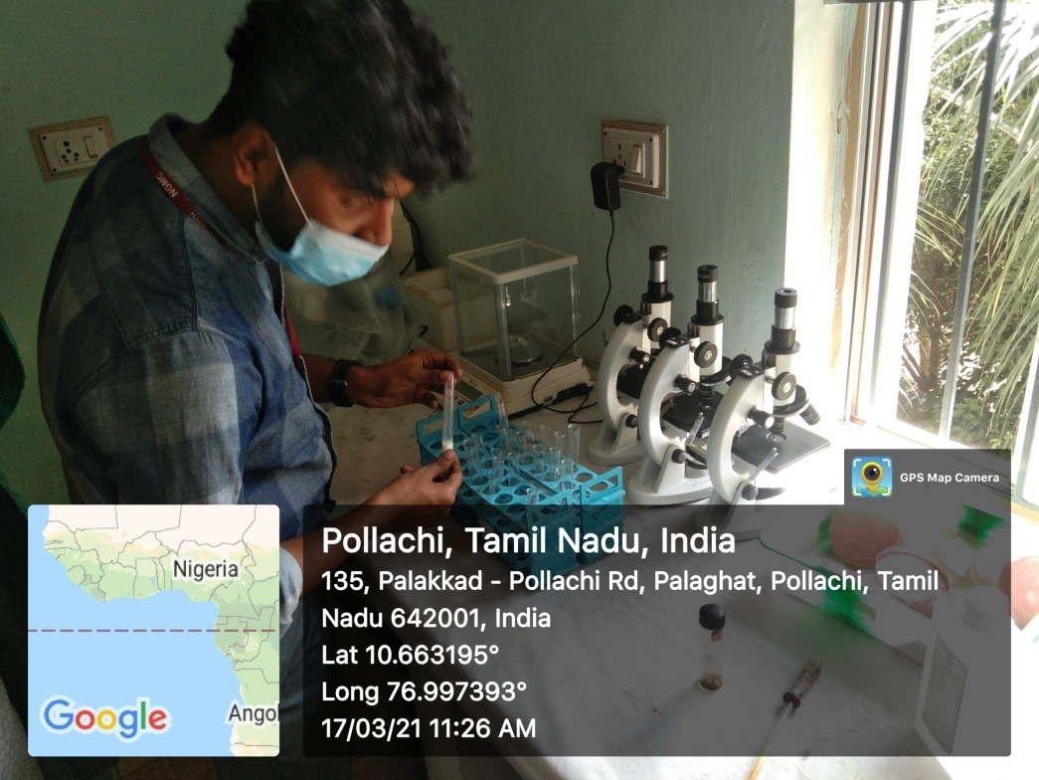

Macro algal culture
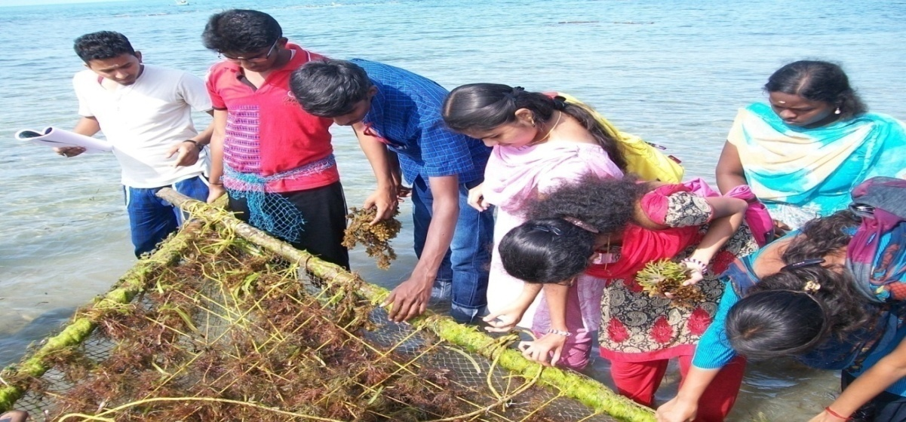

Seaweed collection
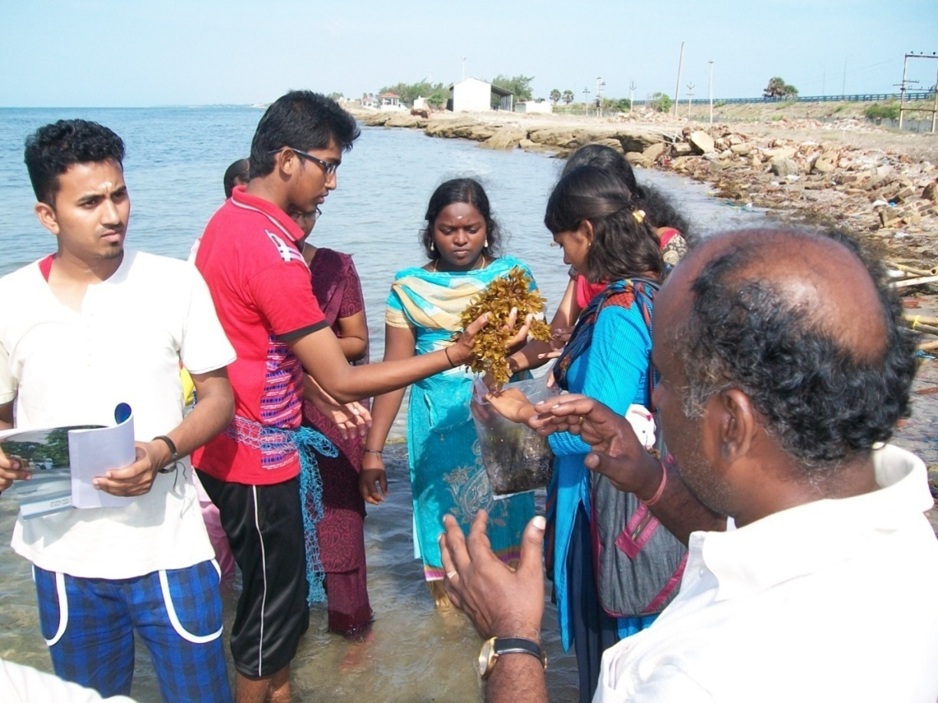
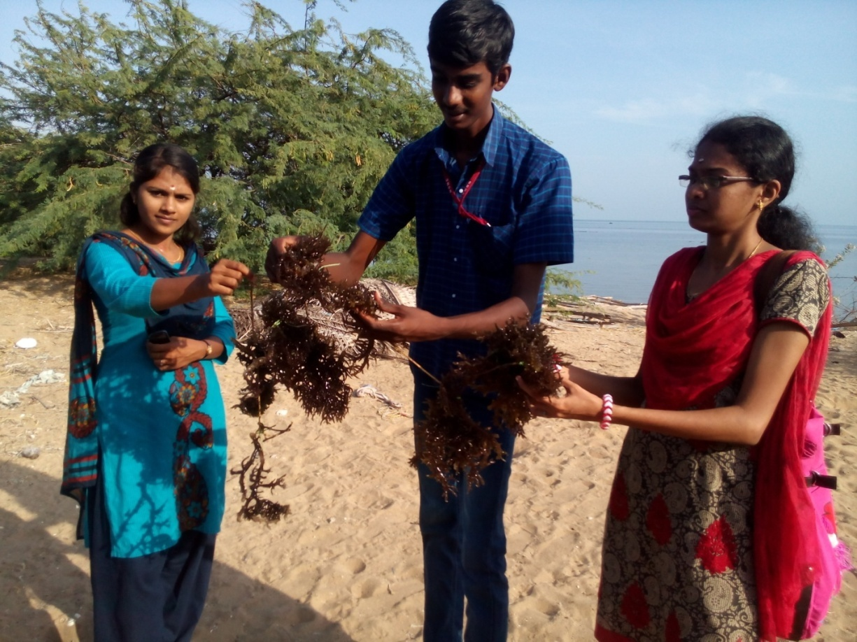
Microbial research
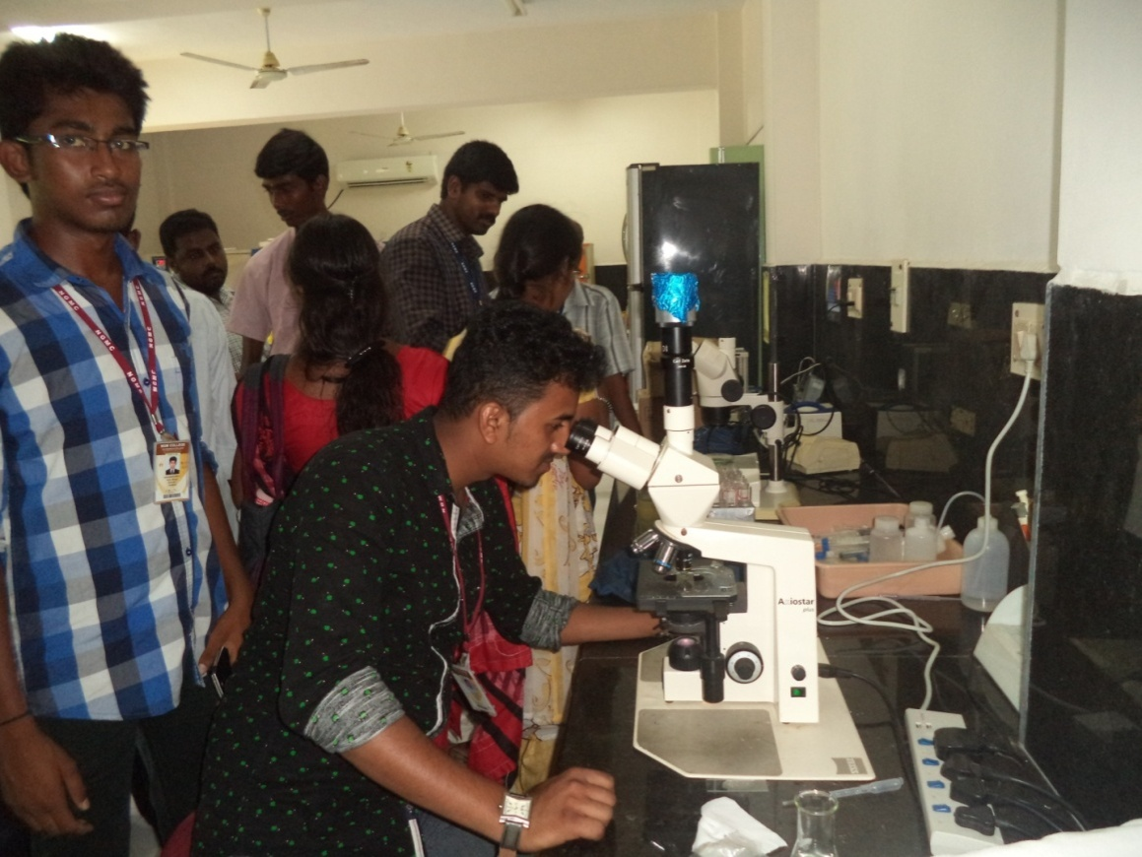
Plant tissue culture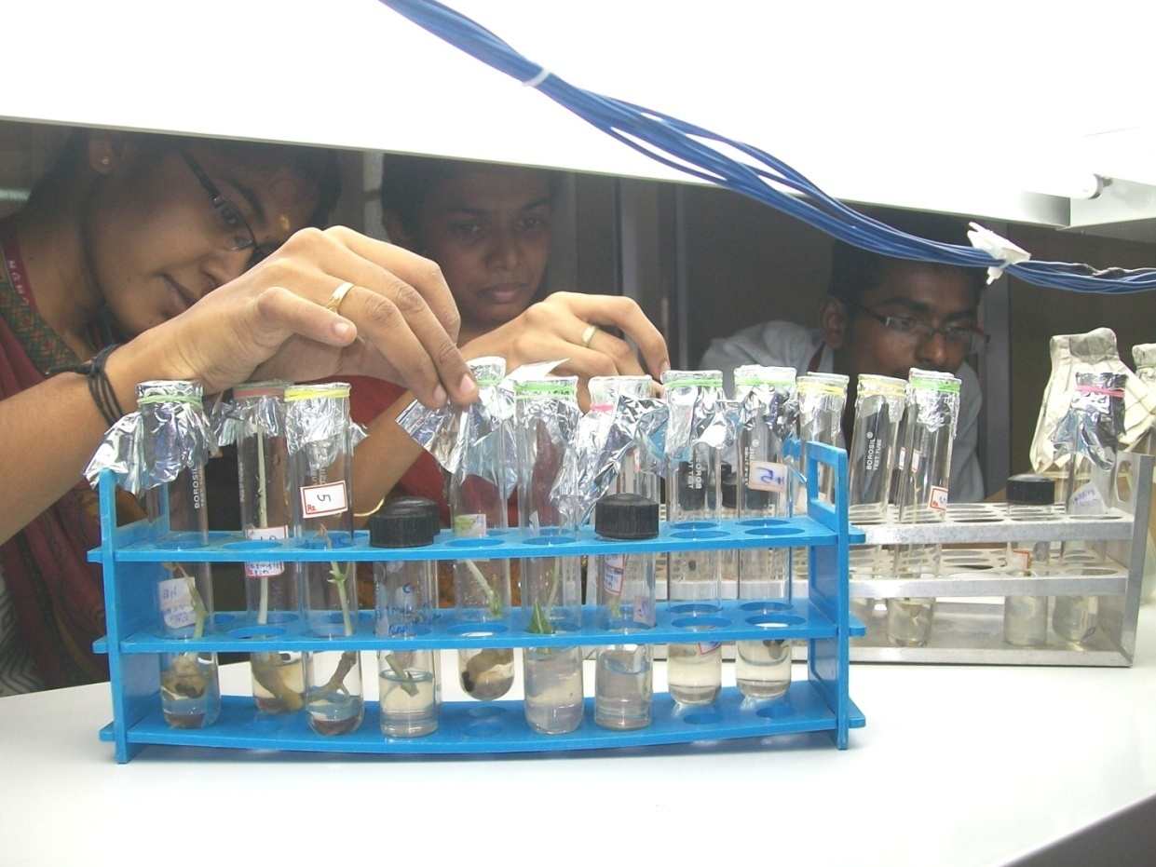
Inoculation of microbes
