
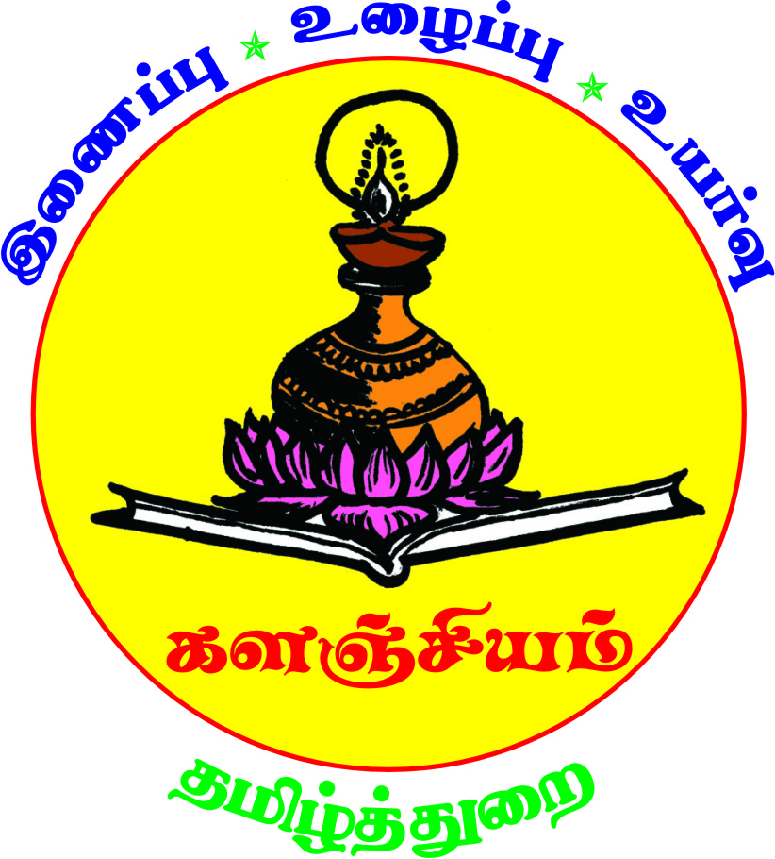
ey;yKj;Jf; fTz;lh; kfhypq;fk; fy;Y}hp
nghs;shr;rp
jkpo;j;Jiw (muR cjtp)
  - Mk; fy;tpahz;bw;fhd jkpo; kd;w epfo;Tfs;

- 29.09.2021 jkpo;j;Jiw elj;Jk; ghujp epidTr; nrhw;nghopT ,izatopapy; eilngw;wJ. jiyth;> irtrpj;jhe;jj;Jiw> nrd;idg;gy;fiyf;fofj;ijr; rhh;e;j Kidth; ey;Y}h; r.rutzd; mth;fs; ‘ghujpapd; ghf;fspy; vopypay;’ vd;Dk; jiyg;gpy; rpwg;Giuahshuhf rpwg;Giuahw;wpdh;.

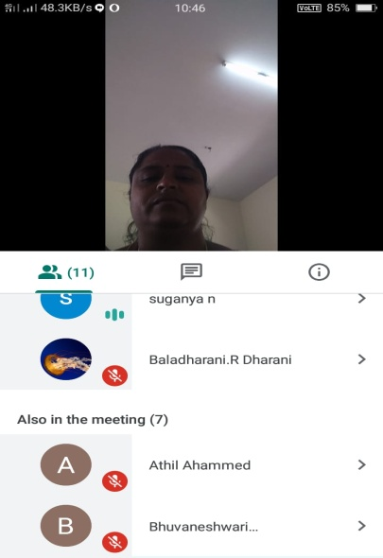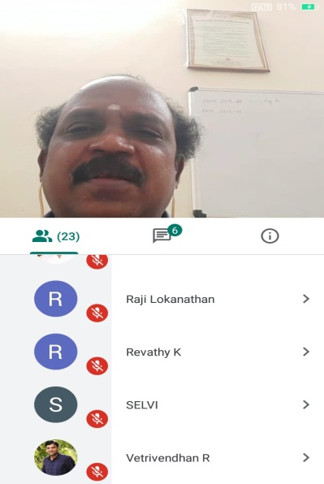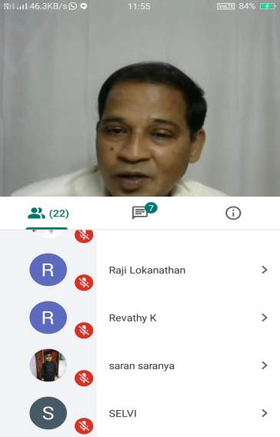

2) 04.12.2021 md;W jkpo;j;Jiw elj;jpa xUehs; Njrpar; Rtbapay; gapyuq;fk;. ,g;gapyuq;fj;jpw;F jQ;irj; jkpo;g; gy;fiyf;fofj;ijr; rhh;e;j gjpthsh; kw;Wk; Rtbapay; Jiwj;jiyth; Kidth; Nkh.Nfh.Nfhitkzp mth;fs; gapw;Weuhf fye;J gapw;rpaspj;jhh;. ,g;gapyuq;fj;jpy; Rkhh; 100 khzth;fs; fye;J nfhz;L gadile;jdh;.

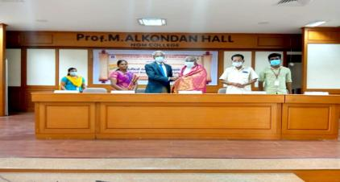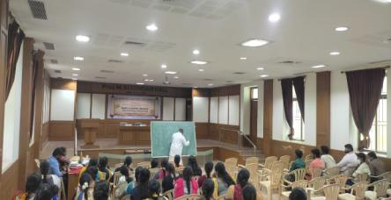
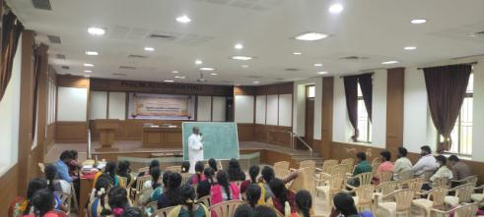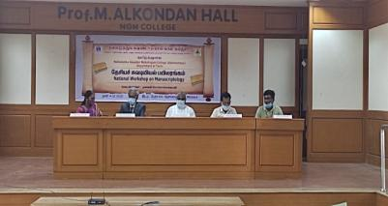

- 11.04.2022 md;W ey;yKj;Jf;fTz;lh; kfhypq;fk; fy;Y}hp jkpo;j;JiwAk;> kNyrpaj;jkpo; vOj;jhsh; rq;fj;jpd; MjpFkzd; mwf;fl;lisAk; ,ize;J elj;jpa cyfshtpa ciuauq;fk;. ,t;Tiuauq;fj;jpw;F fy;Y}hp Kjy;th; jiyikjhq;fpdhh;. MjpFkzd; mwf;fl;lisapd; epWtd cWg;gpdh; jpU.Nr.tpj;ahrhfh; tuNtw;Giuahw;wpdhh;. kNyrpa vOj;jhsh; rq;fj;jiyth; jpU.ng.,uhN[e;jpud; mth;fSk;> Nfhit ekJek;gpf;if ,jopd; Mrphpah; jpU.kugpd;ike;jd; Kj;ijah mth;fSk; rpwg;Giuahw;wpdh;. jkpo;cjtpg;Nguhrphpah; Kidth; f.jdyl;Rkp mth;fs; ed;wpAiuahw;wpdhh;.500f;Fk; Nkw;gl;l khzth;fs; fye;Jnfhz;L gadile;jdh;.

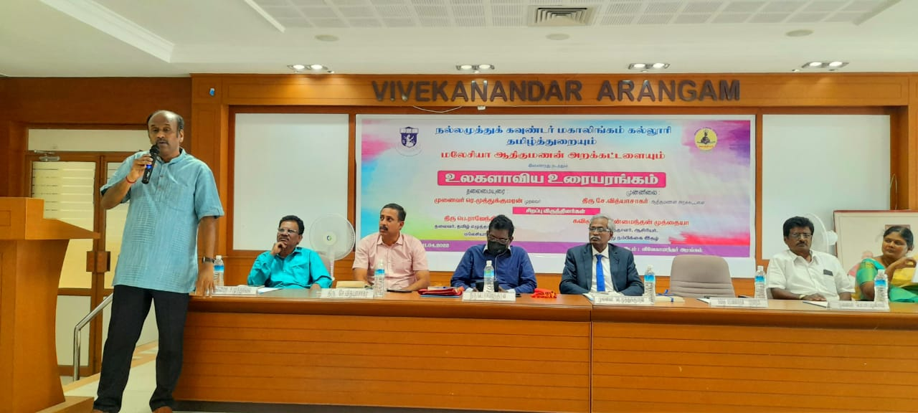
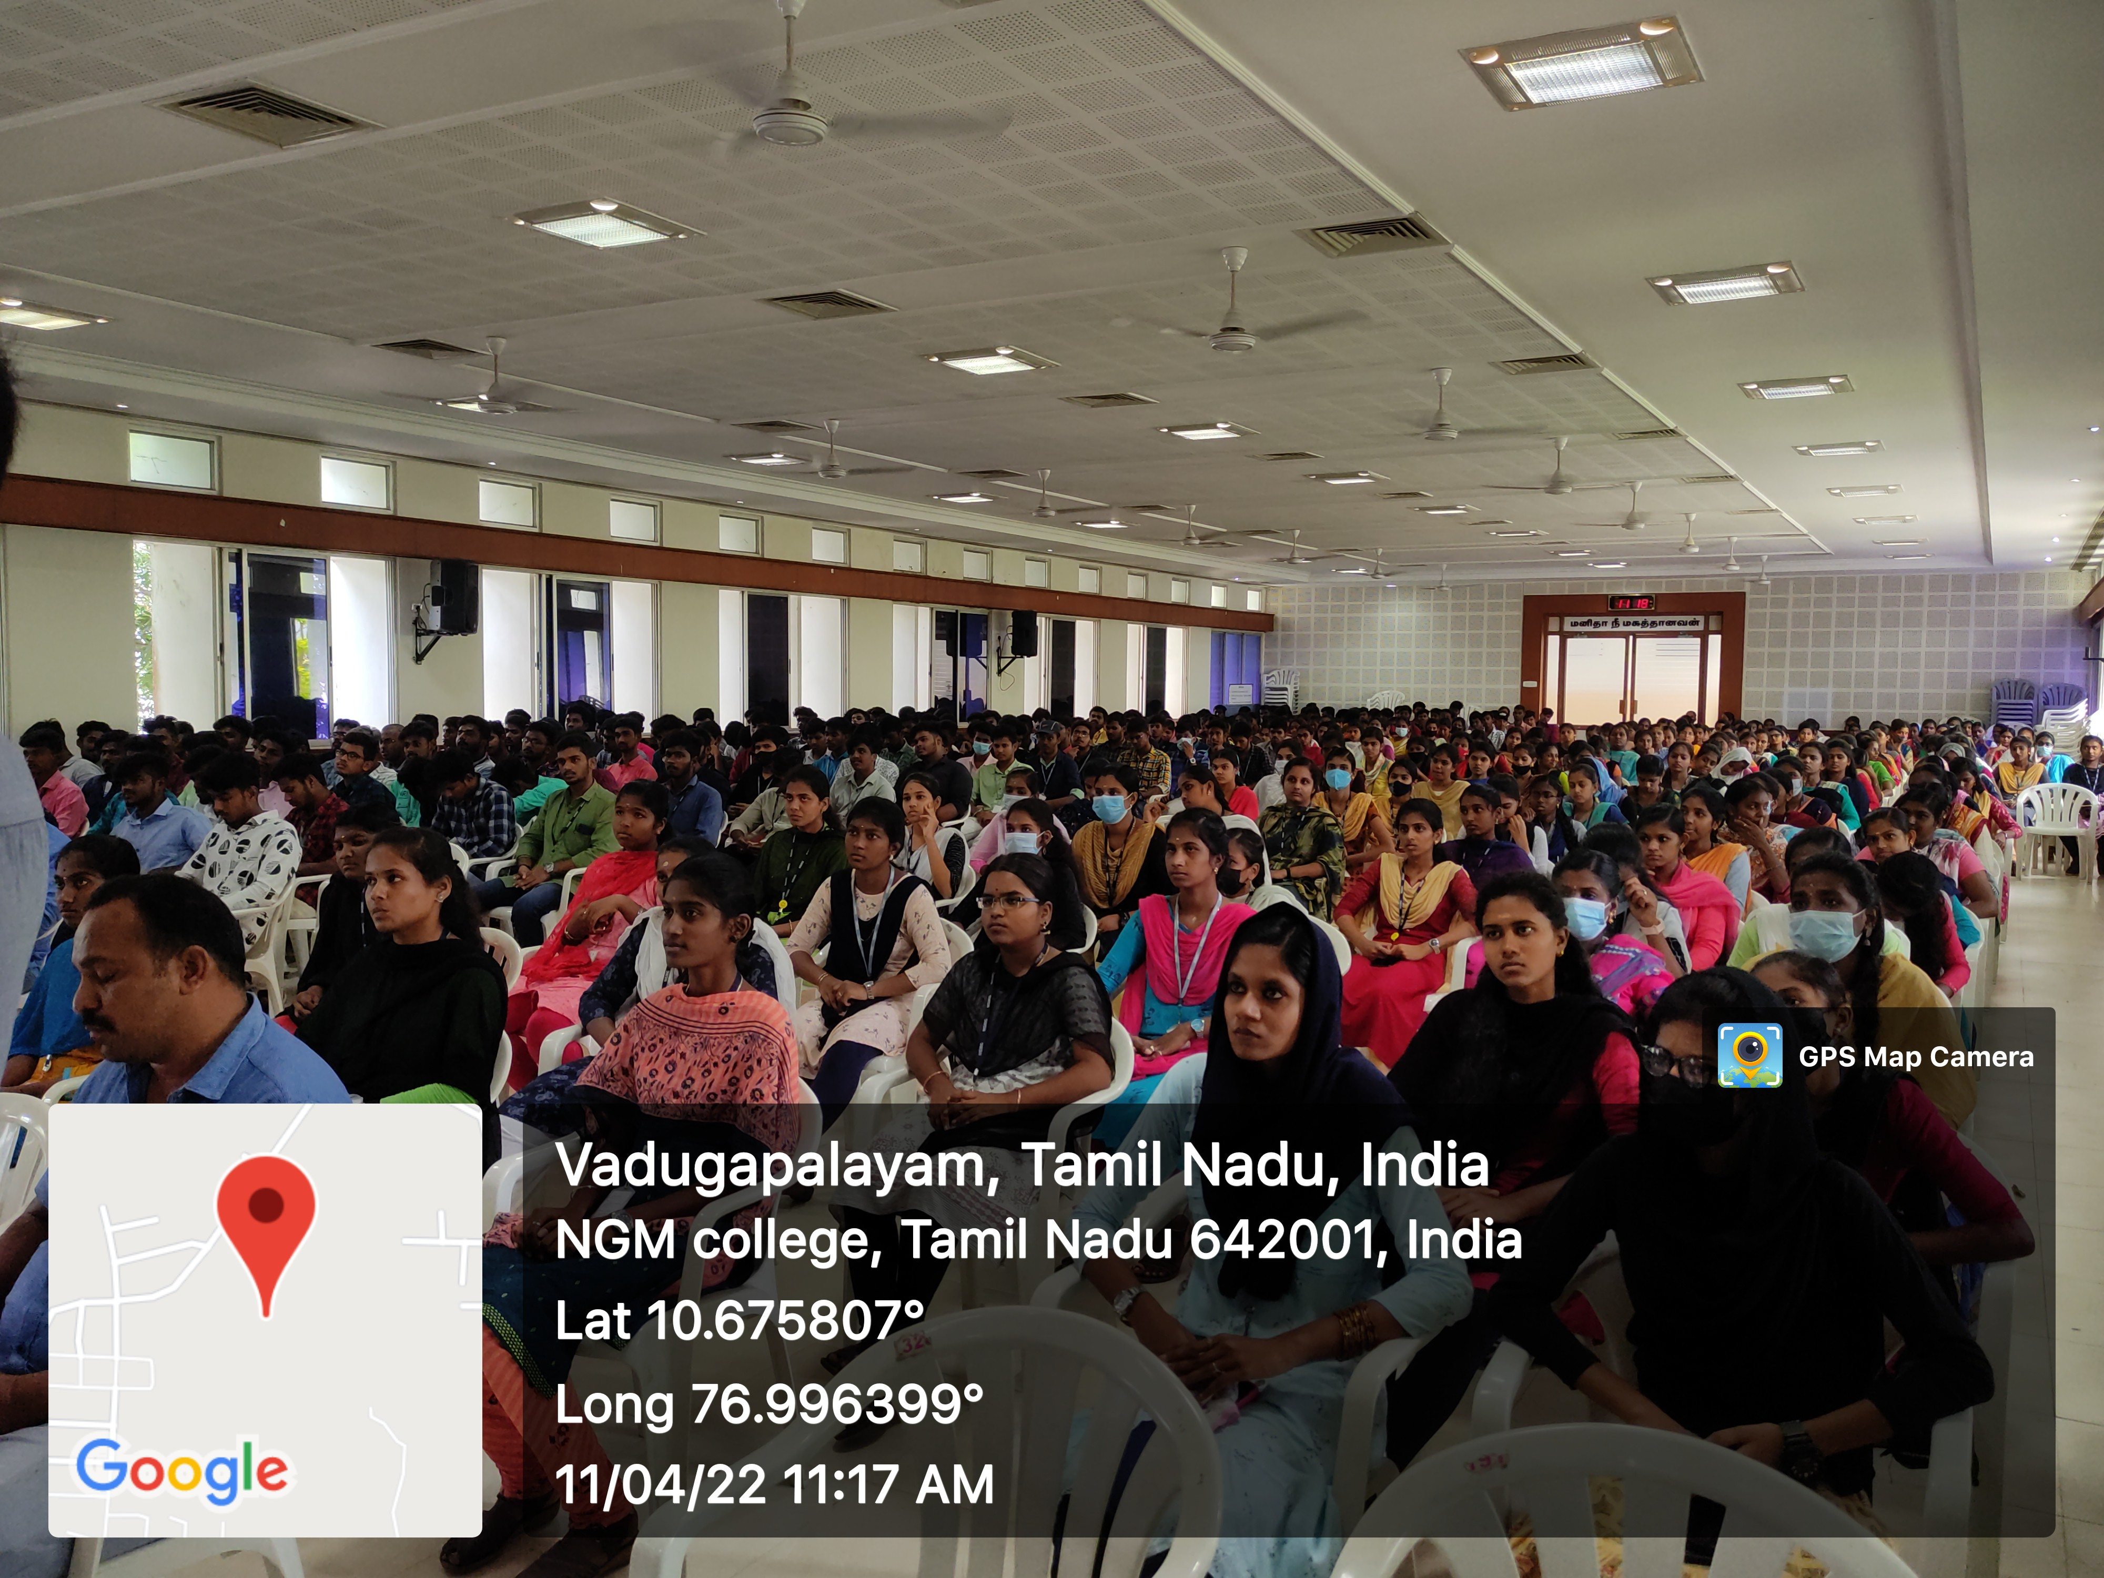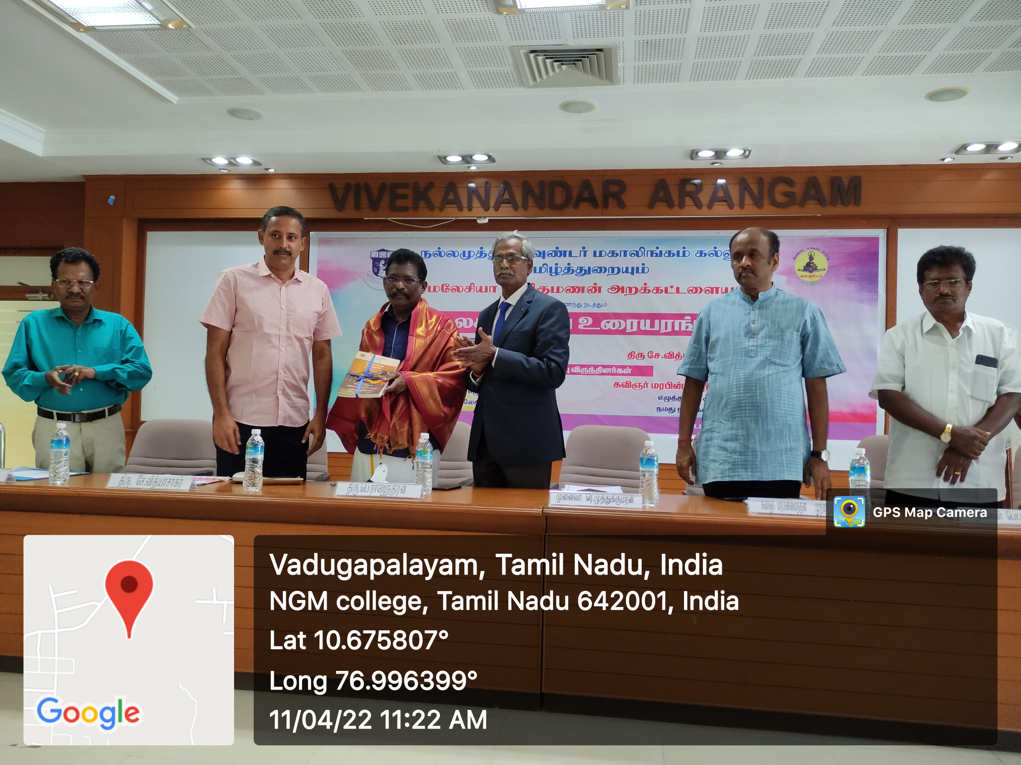

4) 12.05.2022 md;W jkpo;j;JiwAk;> jkpo; Ma;thsh; kd;wKk; ,ize;J Kd;dhs; Kjy;th; ngh.kh.godprhkp mth;fSf;F epidtiy E}y; ntspaPl;L tpoh eilngw;wJ. ,t;tpohtpy; gj;k = ftpQh; rpw;gp ghyRg;gpukzpak; mth;fs; rpwg;Giuahw;wpdhh;. Kidth; mKjd; ghuhl;Liu toq;fpdhh;. Kidth; j.uh[;Fkhh; kfpo;Tiu toq;fpdhh;. Kidth; ngh.kh.godprhkp mth;fs; Vw;Giu ey;fpdhh;.
5) 10.03.2022 md;W ey;yKj;Jf;fTz;lh; kfhypq;fk; fy;Y}hp jkpo;j;Jiwapy; jkpo; ,yf;fpaq;fspy; nrhy;tsKk; nghUs;tsKk; vd;w jiyg;gpy; gd;dhl;Lf; fUj;juq;fk; ,izatopapy; eilngw;wJ. ,jpy; Kidth; f.fjputd;> Jizg;Nguhrphpah;> jkpo;j;Jiw Ma;Tikak;> muRf;fy;Y}hp> rpj;J}h;> Nfusk; rhh;e;j Nguhrphpah; mth;fs; rpwg;G tpUe;jpduhff; fye;J nfhz;L gy;NtW jfty;fis vLj;Jiuj;jhh;.Kidth; j.guNk];thp(Raepjpj;Jiwj;jiyth;) kw;Wk; Kidth; j.uh[;Fkhh; (,yf;fpaj;Jiwj;jiyth;) mth;fs; jiyik tfpj;jdh;.
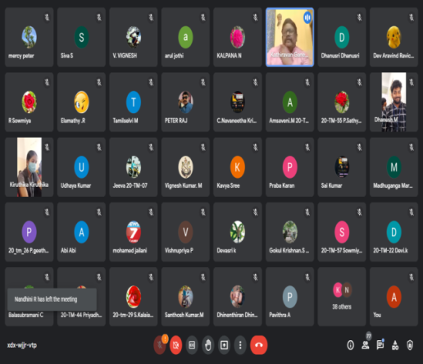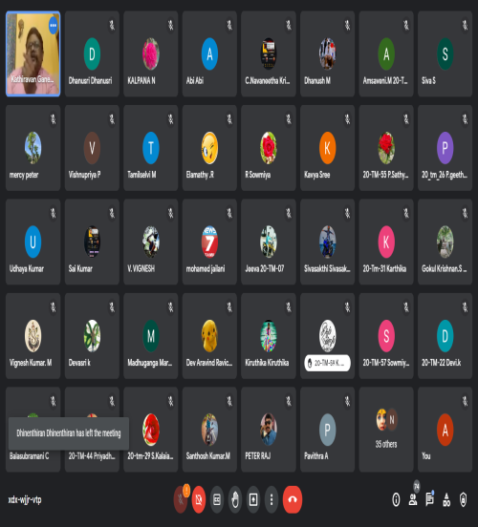
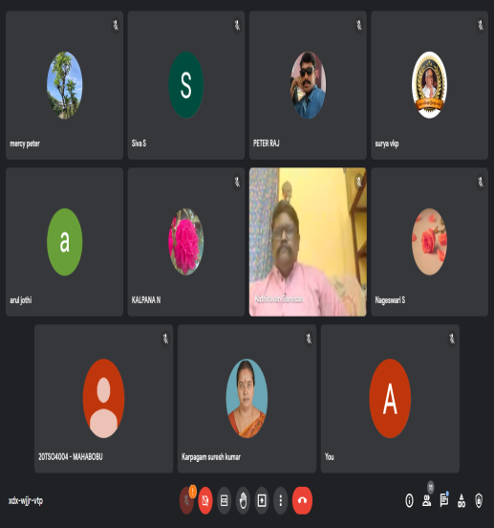

ey;yKj;Jf; fTz;lh; kfhypq;fk; fy;Y}hp
nghs;shr;rp
jkpo;j;Jiw (muR cjtp)
Coy; tpopg;Gzh;T
2.11.2022 md;W fhiy 10.00 kzpastpy; tpNtfhde;jh; muq;fj;jpy; tUkhd thpj;JiwAk; jkpo;j;JiwAk; ,ize;J Coy; tpopg;Gzh;T thuk; tphpthf;fg;gzp – eilngw;wJ. ,e;epfo;tpy; khzth;fSf;fhd Coyw;w ,e;jpah – tsh;r;rpaile;j ,e;jpah vd;w jiyg;gpy; fl;Liug;Nghl;b elj;jg;ngw;wJ. ,g;Nghl;bapy; Rkhh; 50 khzth;fs; fye;J nfhz;ldh;.
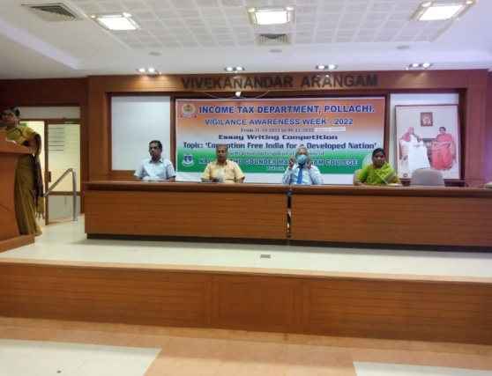
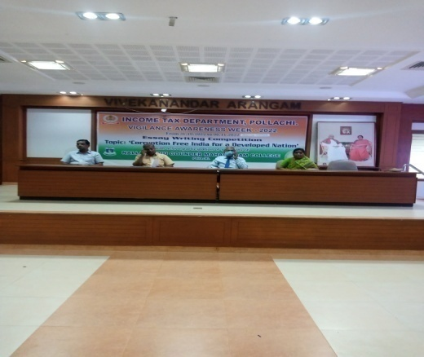

ey;yKj;Jf; fTz;lh; kfhypq;fk; fy;Y}hp
nghs;shr;rp
jkpo;j;Jiw (muR cjtp)
rpj;jkUj;Jt MNyhrid Kfhk;
26.11.2022 md;W fhiy 10.30 kzpastpy; Nfrt;tpj;ahke;jph; nkl;hpf;Nky;epiyg;gs;spapy; jkpo;j;JiwAk; mUl;nry;th; khzth; rpe;jid kd;wKk; ,ize;J rpj;jkUj;Jt MNyhrid Kfhk; eilngw;wJ. ,e;epfo;tpy; Rkhh; 30 Mrphpah;fs; kw;Wk; 100 khzth;fs; fye;J nfhz;L gadile;jdh;. IQAC/2022-23/NOV/164
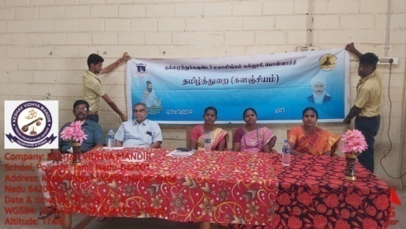
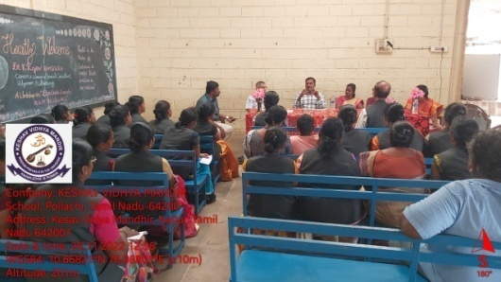

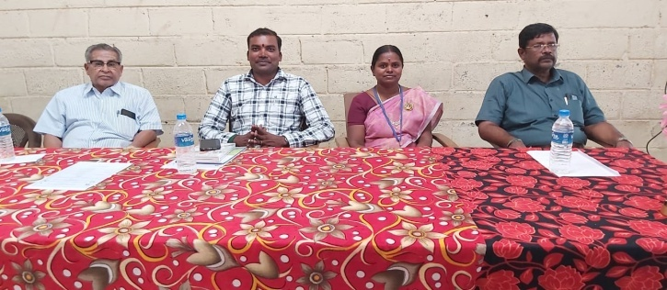

ey;yKj;Jf; fTz;lh; kfhypq;fk; fy;Y}hp
nghs;shr;rp
jkpo;j;Jiw (muR cjtp)
tpdhb tpdh
24.11.2022 md;W Nghl;bj;Njh;Tf;fhd gapw;rp tFg;G elj;jg;gl;lJ. ,g;gapw;rp tFg;gpidf; fy;Y}hp Kjy;th; Kidth; nu.Kj;Jf;Fkud; mth;fs; njhlq;fp rpwg;gpj;jhh;. jkpo;j;Jiwj;jiyth; Kidth; Ng.kN`];thp mth;fs; tuNtw;Giuahw;wpdhh;. jkpo; cjtpg;Nguhrphpah; Kidth; f.jdyl;Rkp mth;fs; ed;wpAiu ey;fpdhh;. khzth;fSf;F tpdhbtpdh Nghl;bAk; elj;jg;gl;lJ.

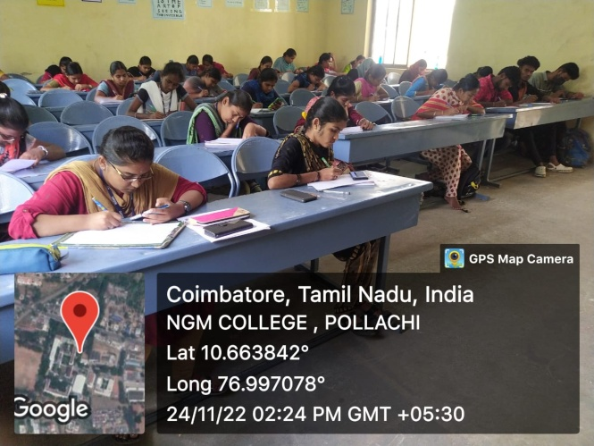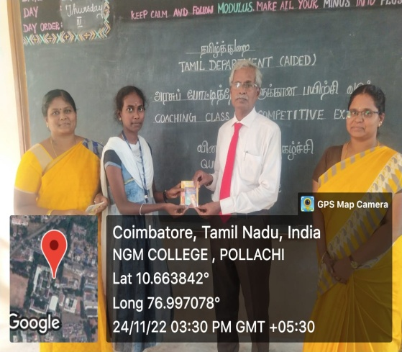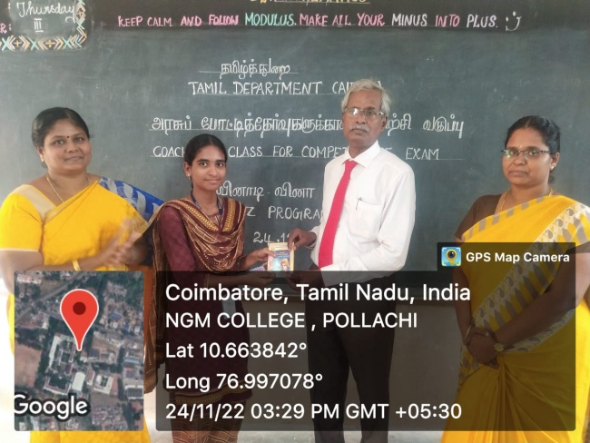

ey;yKj;Jf;fTz;lh; kfhypq;fk; fy;Y}hp
nghs;shr;rp
jkpo;j;Jiw 2022-23

- 06.02.2023 k.uh.Ngh.FUrhkp E}w;whz;L tpoh gj;k= rpw;gp ghyRg;gpukzpak; Nkdhs; jkpo;j;Jiwj;jiytu; ghujpahu; gy;fiyf;fofk; (Nfhit) mtu;fs; NgUiuahw;wpdhu;. rpwg;Giuahsu;fshf Kidtu; ,uh.f.khzpf;fk; Nkdhs; Kjy;tu; fhkNjD fiy mwptpay; fy;Y}up (rj;jpakq;fyk;) mtu;fs;> Kidtu; rp.kh.utpr;re;jpud; Nkdhs; jkpo;j;Jiwj;jiytu; ghujpahu; gy;fiyf;fofk; (Nfhit) mtu;fs; rpwg;Giuahw;wpdh;.
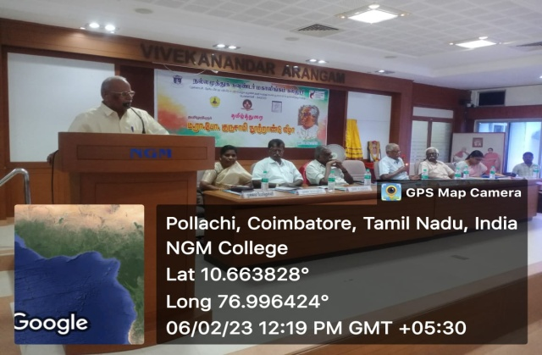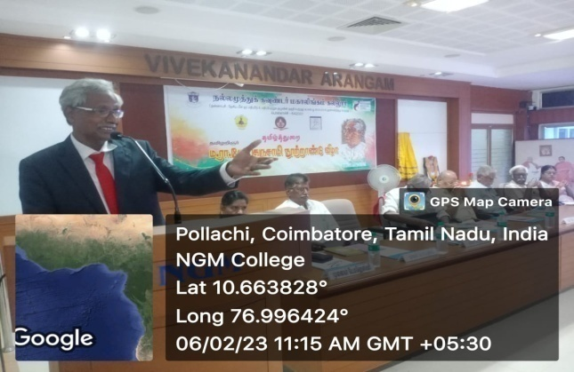

- 23.01.2023 md;W rpWfijg; gapyuq;fk; eilngw;wJ. ,e;epfo;tpy; Kidth; M.jz;lghzp> tdr;ruf mYtyh; mth;fs; rpwg;G tpUe;jpduhff; fye;J nfhz;L rpWfij vOJtJ Fwpj;Jg; gapw;rpaspj;jhh;.

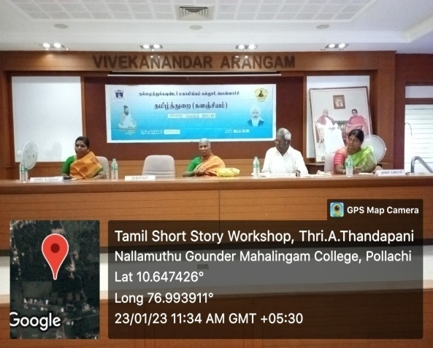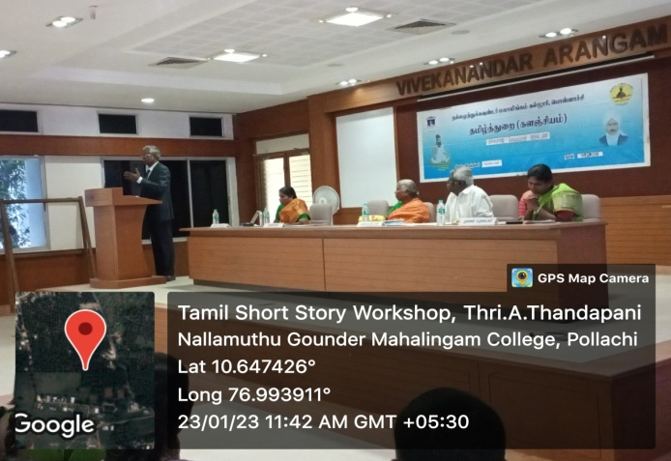

ey;yKj;Jf; fTz;lh; kfhypq;fk; fy;Y}hp
nghs;shr;rp
jkpo;j;Jiw (muR cjtp)
rpwg;Gr;nrhw;nghopT
05.04.2023 md;W ey;yKj;Jf;fTz;lh; kfhypq;fk; fy;Y}hpj; jkpo;j;JiwAk;> kdpjts khz;Gj;JiwAk; ,ize;J elj;jpa rpwg;Gr;nrhw;nghopT ,dpNj eilngw;wJ. fy;Y}hp Kjy;th; mth;fs; njhlq;fp itj;J jiyikAiuahw;wpdhh;. rpwg;G tpUe;jpdh; fpU\;zFkhh; mth;fs; cly; MNuhf;fpak; Fwpj;j gy;NtW jfty;fis khzth;fSf;Fk;> Nguhrphpah;fSf;Fk; vLj;Jiuj;jhh;.
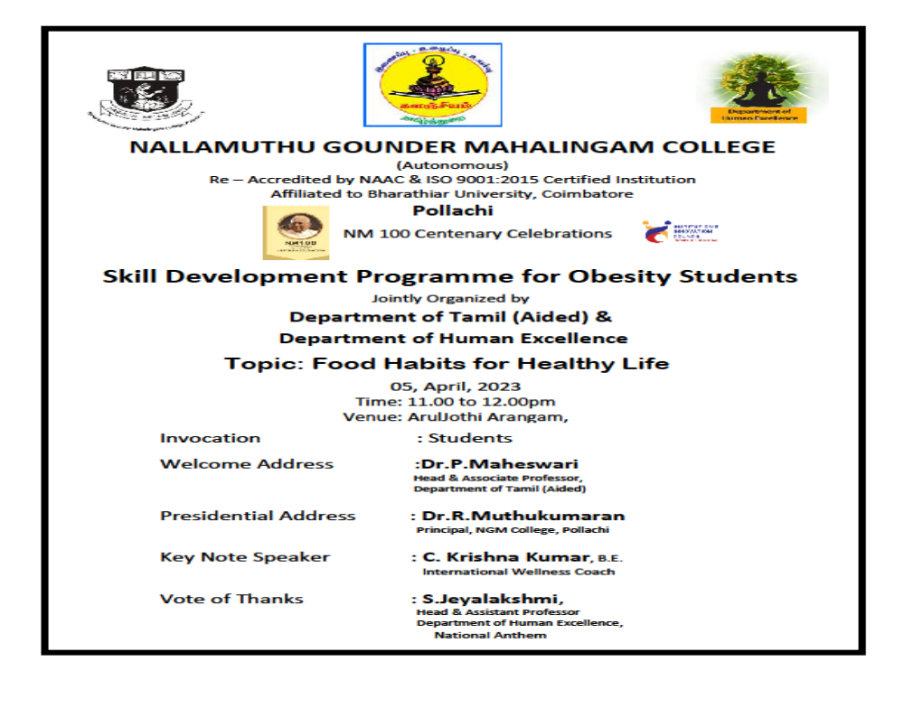
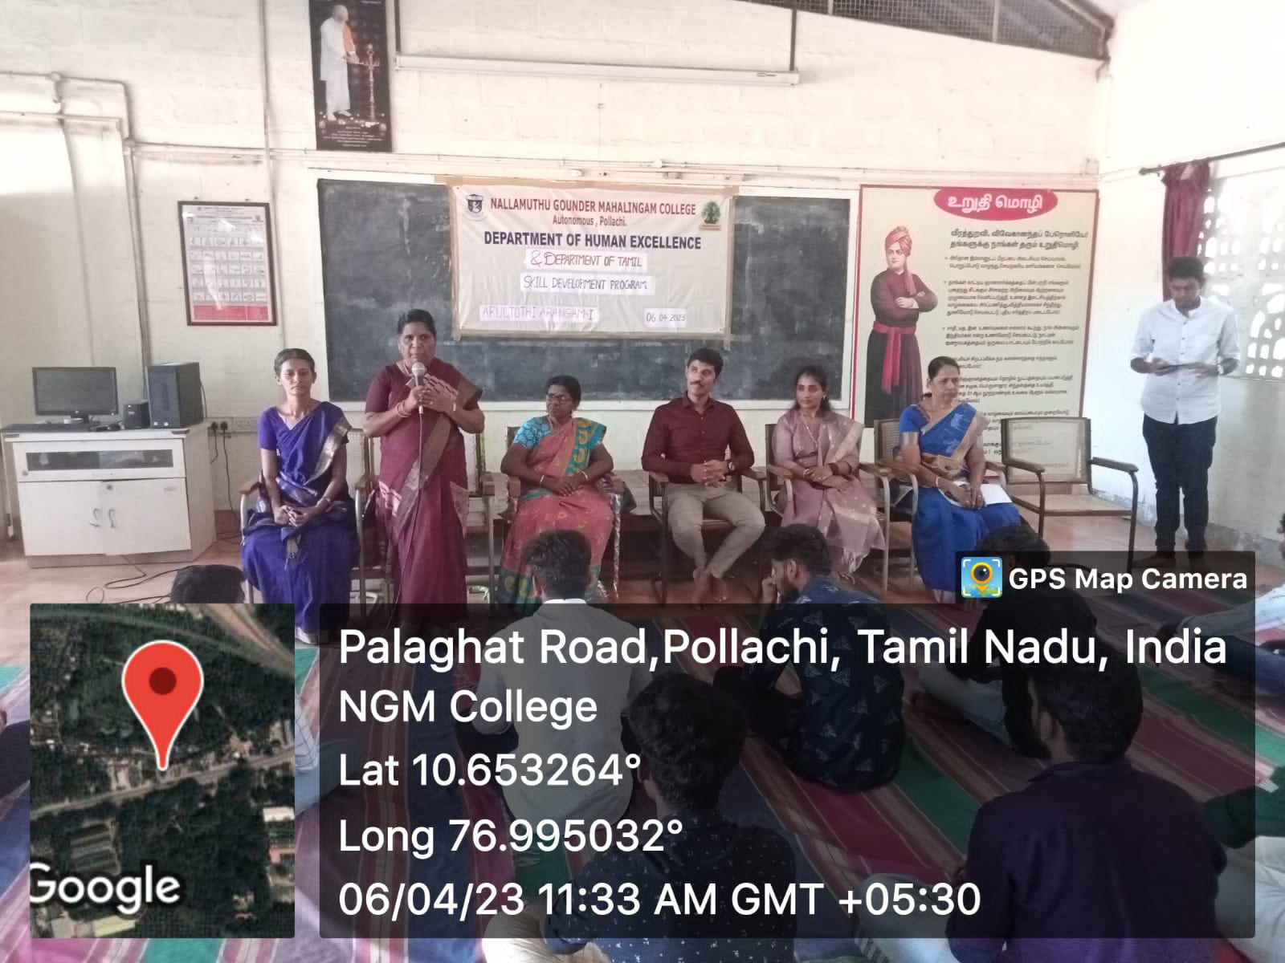
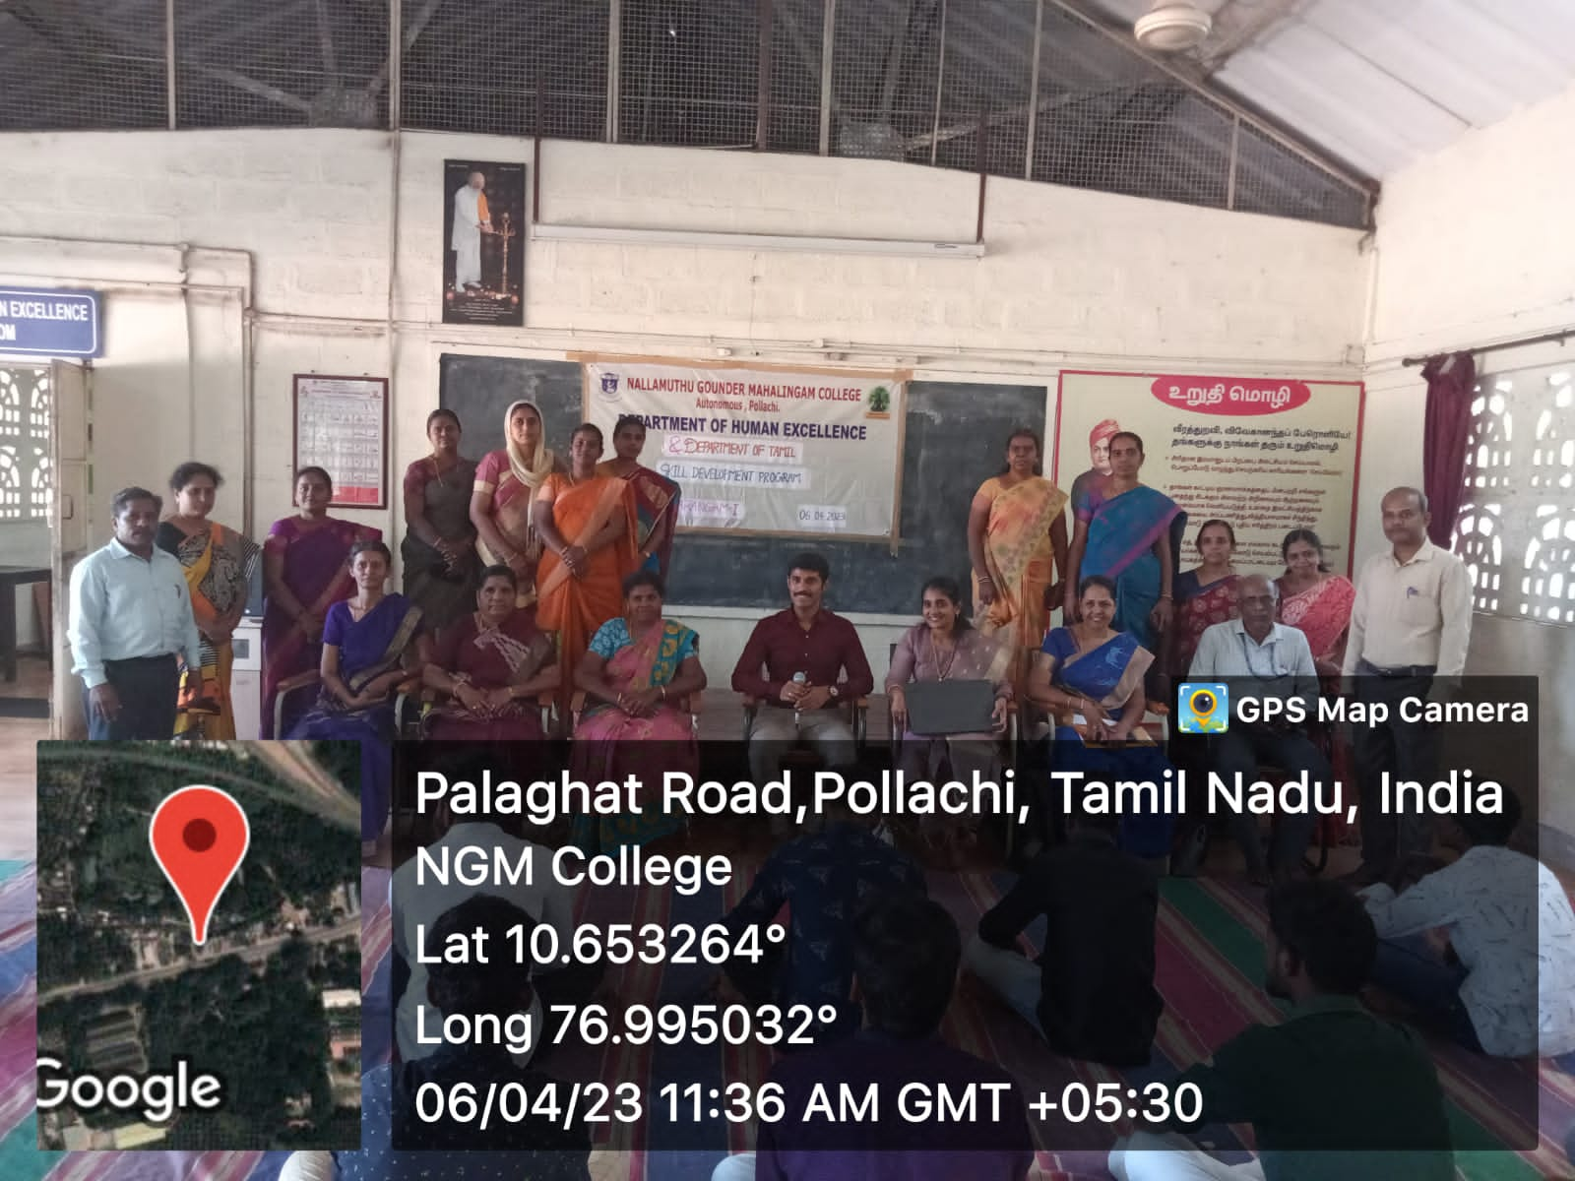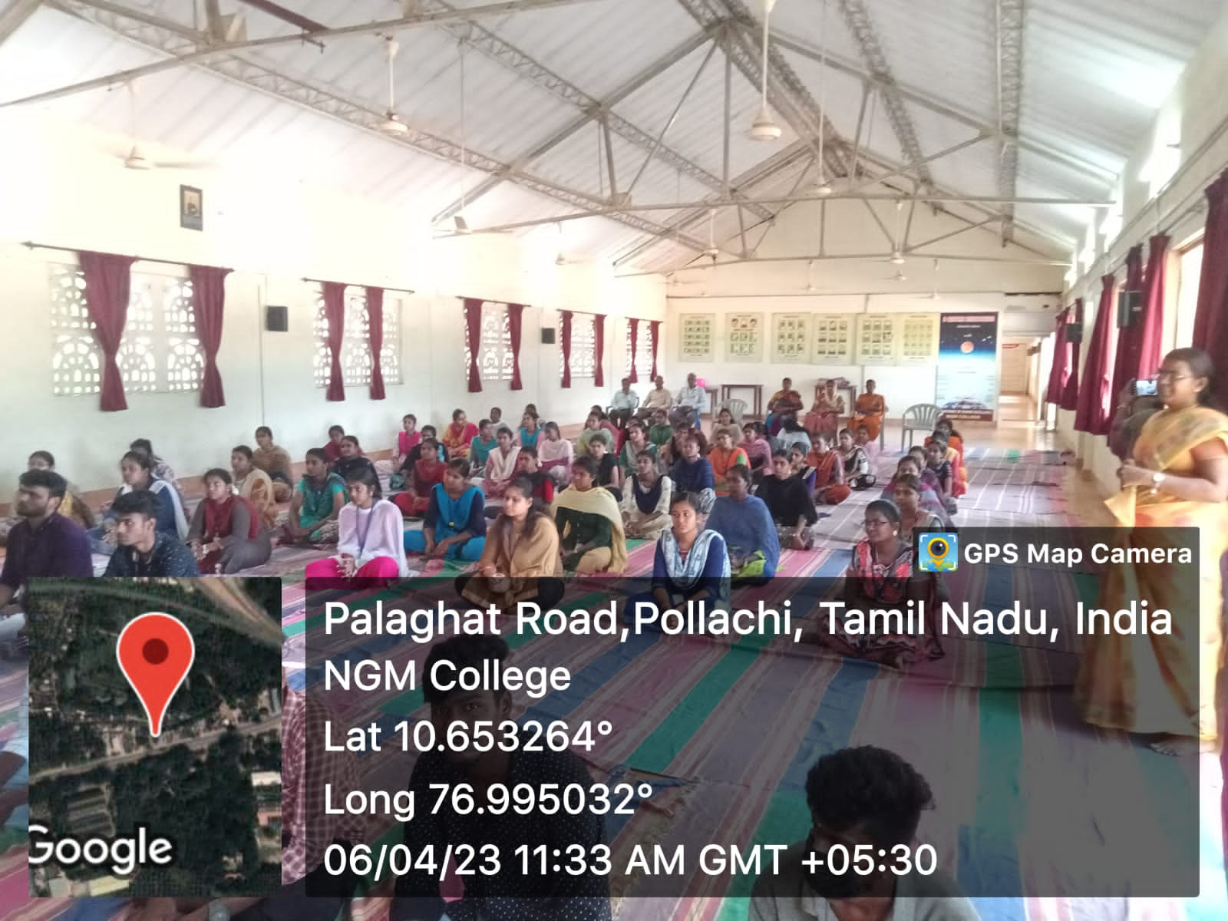

ey;yKj;Jf; fTz;lh; kfhypq;fk; fy;Y}hp
nghs;shr;rp
jkpo;j;Jiw (muR cjtp)
gd;dhl;Lf;fUj;juq;fk;
ey;yKj;Jf;fTz;lh; kfhypq;fk; fy;Y}hp jkpo;j;JiwAk;> jkpo;j;Jiw Ma;tshh; kd;wKk; ,ize;J xUehs; gd;dhl;Lf; fUj;juq;fk; eilngw;wJ. ,e;epfo;tpy; rpj;J}h; muRf;fiyf;fy;Y}hp Nguhrphpah; f.rptkzp mth;fs; rpwg;Giuahw;wpdhh;. Kidth; uk;ah mth;fs; ,f;fUj;juq;f xUq;fpizg;ghshuhf ,e;epfo;tpid rpwg;ghf elj;jpdhh;.
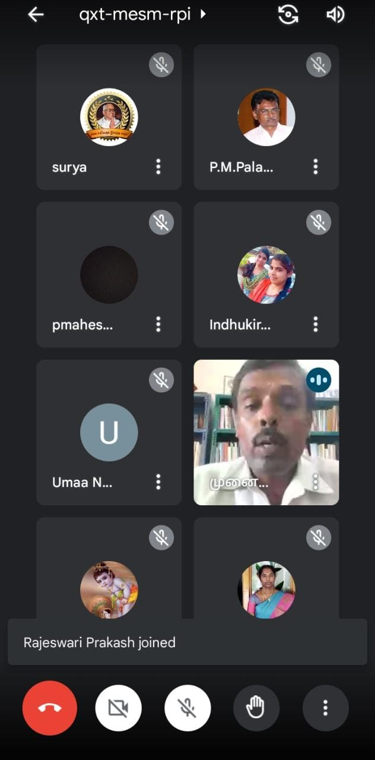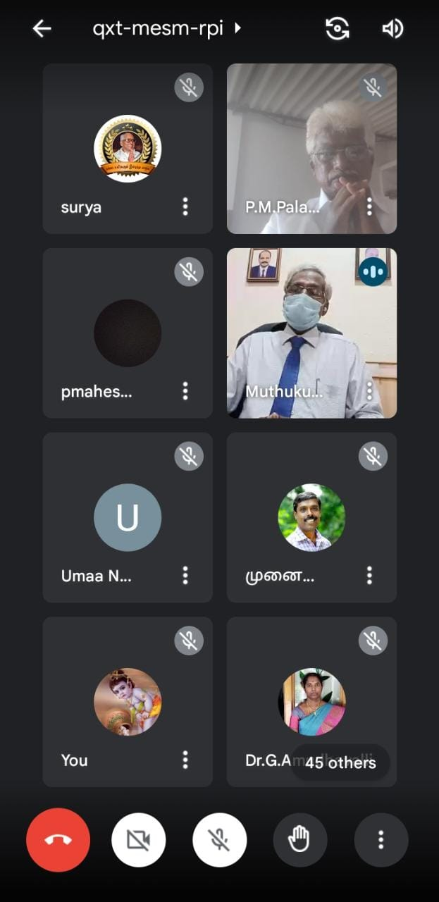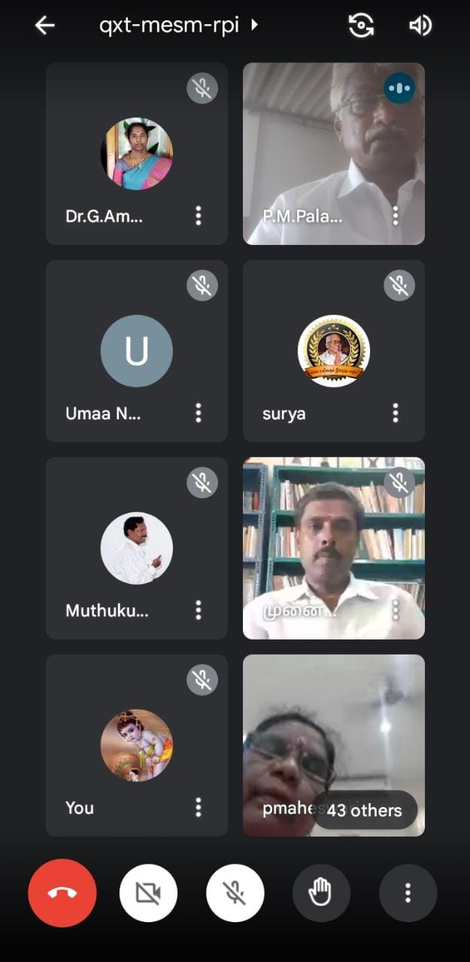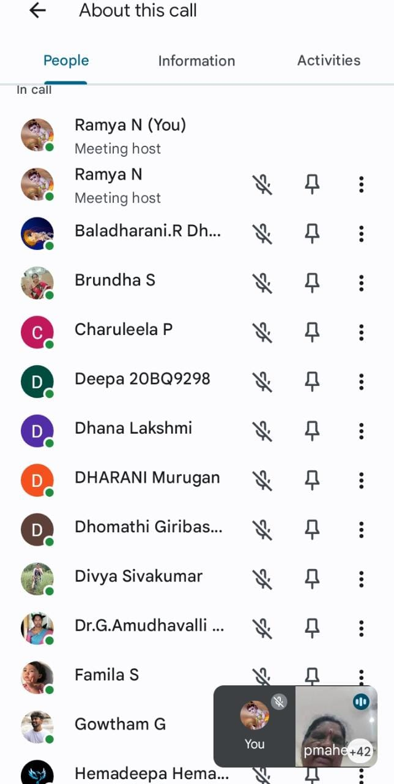
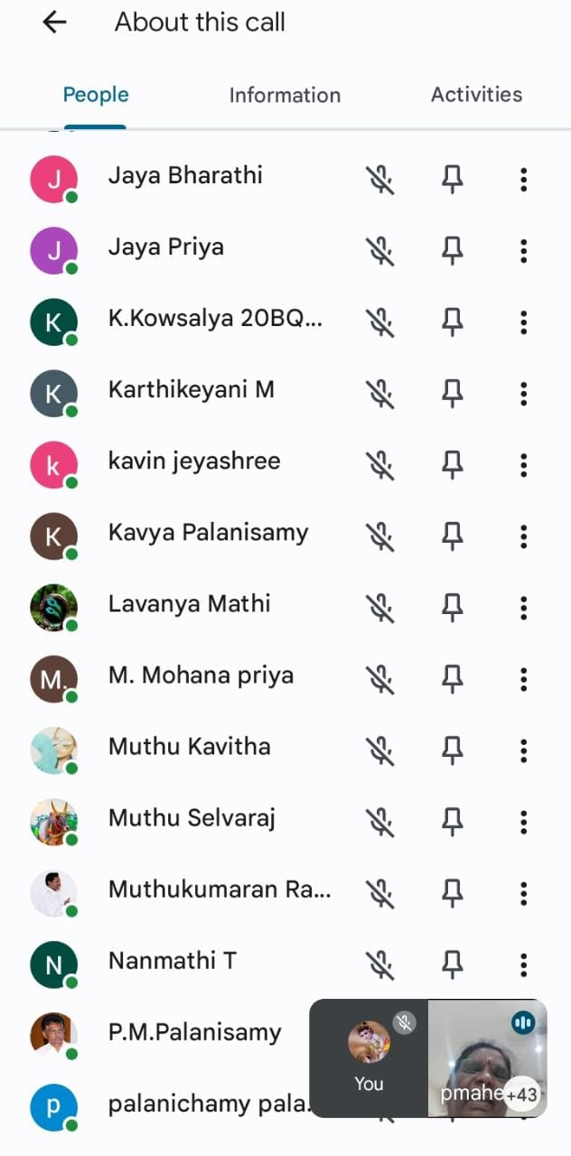

ey;yKj;Jf; fTz;lh; kfhypq;fk; fy;Y}hp
nghs;shr;rp
jkpo;j;Jiw (muR cjtp)
ngz;fSf;fhd Ranjhopy; njhlq;Fjy;
gapyuq;fk;
25.04.2023 md;W jkpo;j;Jiw (muRcjtp) elj;jpa khztpfSf;fhd Ranjhopy; njhlq;Fjy; Fwpj;jhd xU ehs; gapyuq;fk; rpwg;ghf eilngw;wJ. ,e;epfo;tpidf; fy;Y}hp Kjy;th; mth;fs; njhlq;fp itj;Jr; rpwg;gpj;jhh;. jkpo;j;Jiwj;jiyth; Kidth;Ng.kN`];thp mth;fs; tuNtw;Giuahw;wpdhh;. ,e;epfo;tpd; xUq;fpizg;ghsh; Kidth;gh.mUs;N[hjp mth;fs; ed;wpAiuahw;wpdhh;. ,e;epfo;tpy; Rkhh; 200 khzth;fs; fye;J nfhz;L gadile;jdh;. Nahfh cjtpg;Nguhrphpah; tPurpj;jptpehafd; mth;fs; fye;J nfhz;L ,dpg;Gtiffs; jahhpj;J tpw;gid nra;tJ Fwpj;Jg; gy;NtW jfty;fis vLj;Jiuj;jhh;.
tuyhw;Wj;Jiw> Kidth; gl;l Ma;thsh; eph;ky; gpurhj; mth;fs; ghid Xtpaq;fs; jPl;LtJ Fwpj;Jk;> mtw;iw tpw;gid nra;J yhgk; <l;LtJ Fwpj;Jk; gapw;rpaspj;jhh;.
jkpo;j;Jiw> Kidth; gl;l Ma;thsh; j.eh;kjhNjtp mth;fs; tisay; Nghd;w myq;fhug;nghUl;fs; nra;tJ Fwpj;Jg; gapw;rpaspj;jhh;.
jkpo;j;Jiw> Kidth; gl;l Ma;thsh;> c.rh[pjh mth;fs; nk`e;jp NghLtJk;> Fwpj;Jk; mjw;fhd njhifapidg; ngWtJ Fwpj;Jk; rpwg;ghfg; gapw;rpaspj;jhh;.

