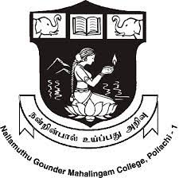 | NallamuthuGounderMahalingam College  (Autonomous)  Re-Accredited by NAAC and ISO 9001:2015 Certified Institution  Affiliated to Bharathiar University, Coimbatore  Pollachi – 642 001
Name of the Workshop/Seminar: Entrepreneurial opportunities in Agricultural crops
Department :PG and Research Department of Botany
Name of the Organizer : Dr. R. Rakkimuthu
Category :Entrepreneur
Date : 24.11.2021 |  | No. of Days : 1
No. of Participants:60
In Collaboration with
Target Audience :Students |  | Beneficiaries of the Event : UG and PG students
Link to the Activity report on the website :
Event ID: IQAC/2021-22/NOV/116

- Circular / Brochure
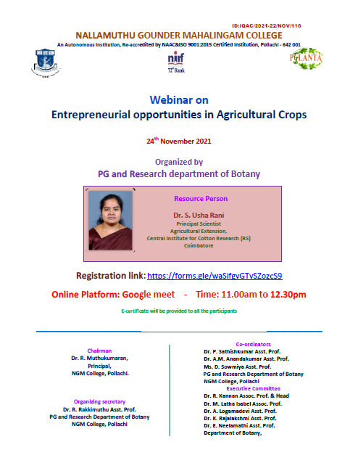

- Detailed Report of the Event
PG and Research Department of Botany, NGM College
Webinar report 2021

Title of the Webinar: Webinar on Entrepreneurial opportunities in Agricultural crops
Aim of the Webinar : The aim of the Webinar is to make aware of participants about
Entrepreneurship opportunities in Agricultural crops and what are the support and incentives available for becoming Agripreneur.

Resource Person : Dr. S. Usha Rani
Principal Scientist
Agricultural Extension,
Central Institute for Cotton Research (RS)
Coimbatore.

Objectives:
- To understand the Entrepreneurial Opportunities in Agricultural crops
- To give overview about Indian Agriculture-Laurels
- To know one’s business success quotient to get success in small scale business
- To know support and incentives, limitations for Agripreneurship

Webinar Summary
PG and Research Department of Botany organized a one day Webinar on “Enterpreneurial opportunities in Agriculural crops” on 24th November 2021, from 11.00 am to 12.30 pm on google meet platform, NGM College, Pollachi. The welcome address was given by A. G. Jana Ranjany, Student Secretary, PG and Research Department of Botany. The webinar brought together over 60 participants from UG and PG Departments of Botany, and various departments, NGM College. The webinar was handled by resource persons from the respective field. The webinar provided an interactive atmosphere between the resource persons and the participants.

The webinar started with general account on Indian Agriculture and its future challenges. It clearly explained about Entrepreneur and its types, Enterpreneurship, Agripreneurs and Agripreneurship, Feasible opportunities of Entrepreneurship in Agriculture and case study on cotton.

Evaluation
Online feedback Evaluation forms was extremely positive. The presentation and theinputs given by the resource persons were highly valued. Participants appreciated for being able to clarify doubts with the experts.

- Geo Tagged photo with Date and Captionand screenshots
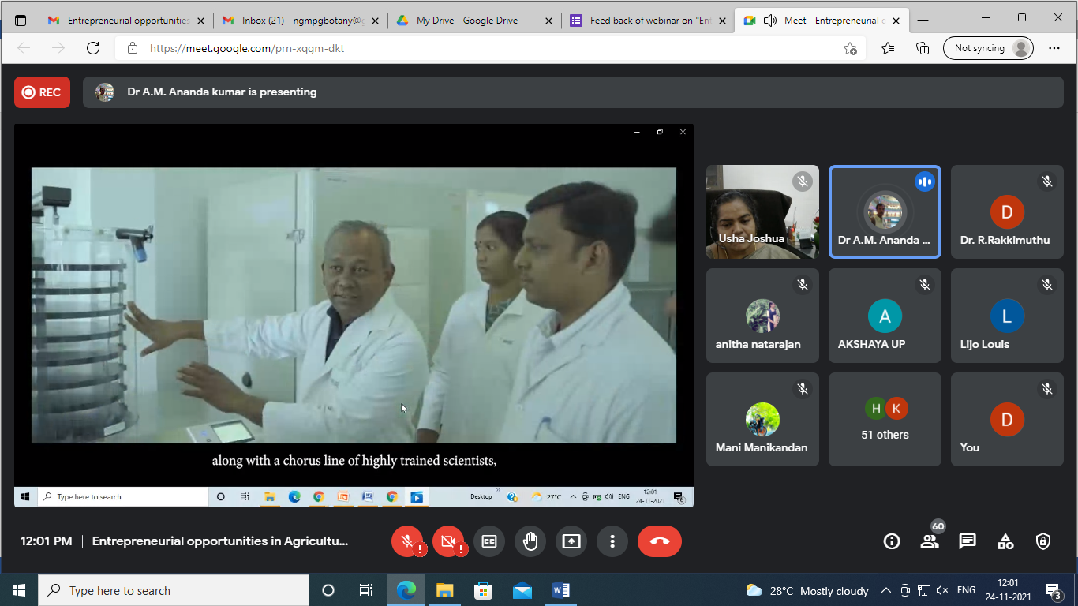
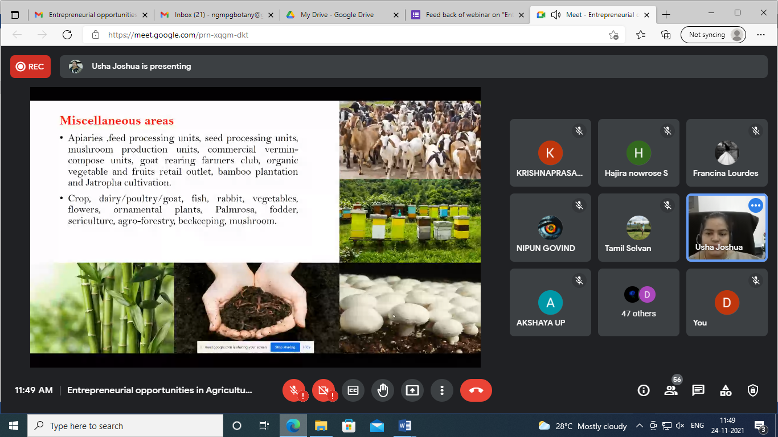

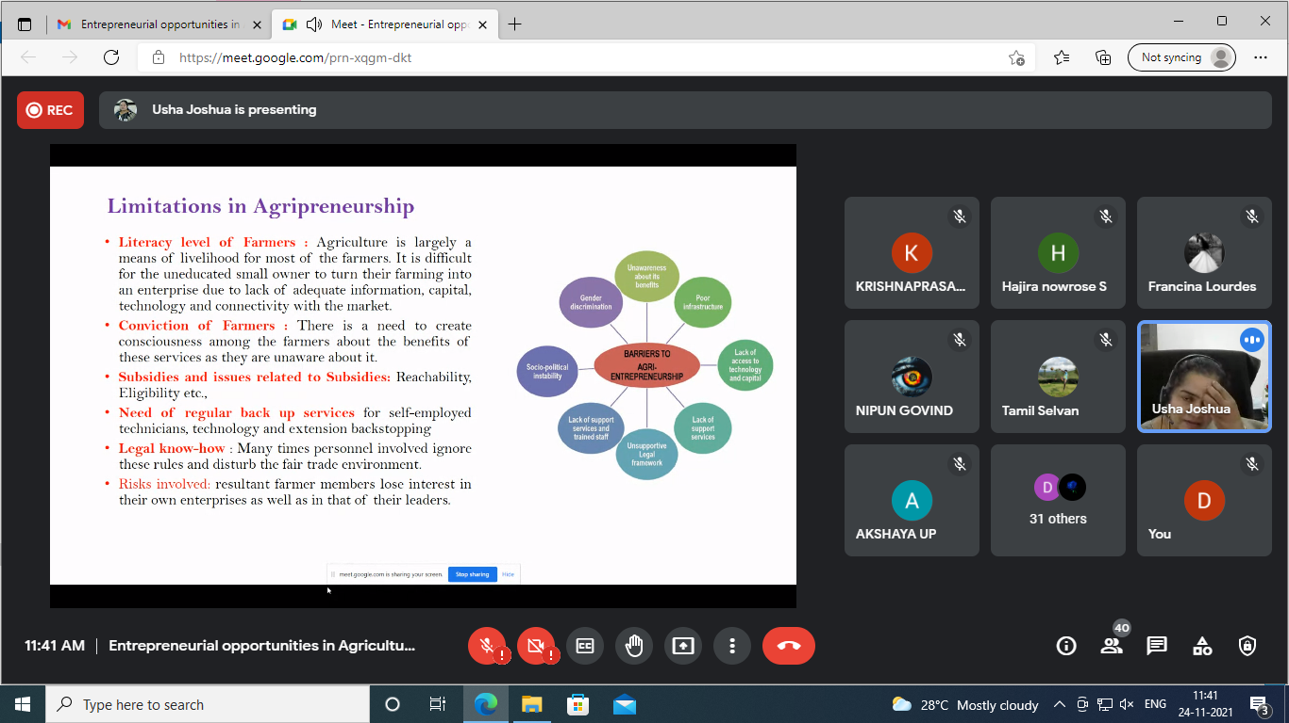

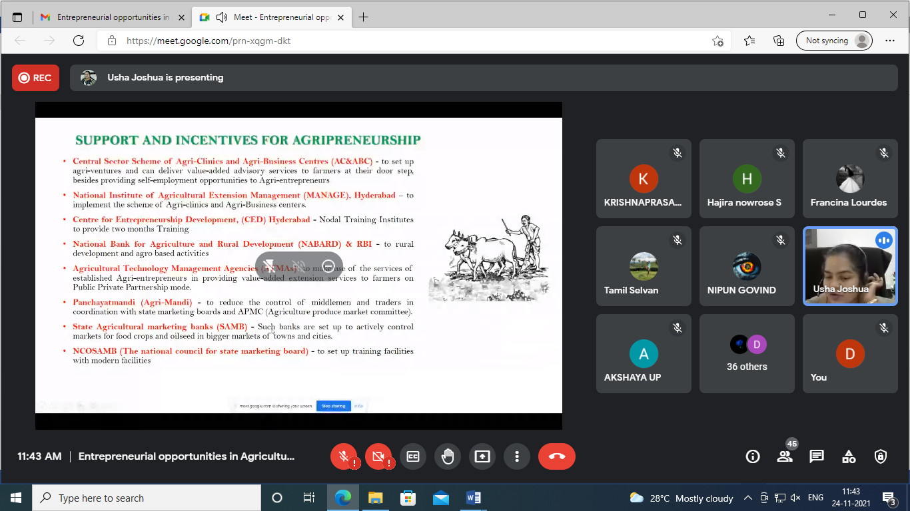

- Attendance ( Name, Designation / Roll No, Signature )
https://docs.google.com/document/d/1-GUL4-BsVf6CSomQEWQ7RI2nfj5-8BUg/edit?usp=sharing&ouid=100636768829908092995&rtpof=true&sd=true
- Feed Back Form
https://drive.google.com/file/d/1fizptrUwZWhXw7BJXuS1piSM1EqsLkzf/view?usp=sharing
- Details of the Resource Person
Dr. S. Usha Rani
Principal Scientist
Agricultural Extension,
Central Institute for Cotton Research (RS)
Coimbatore.

7. Any Other Documents
The recorded webinar video link
https://youtu.be/gANXiYbf3ZQ

