Session 1
Dr.Nirrmala Sathish
Assistant Professor
Department of Economics
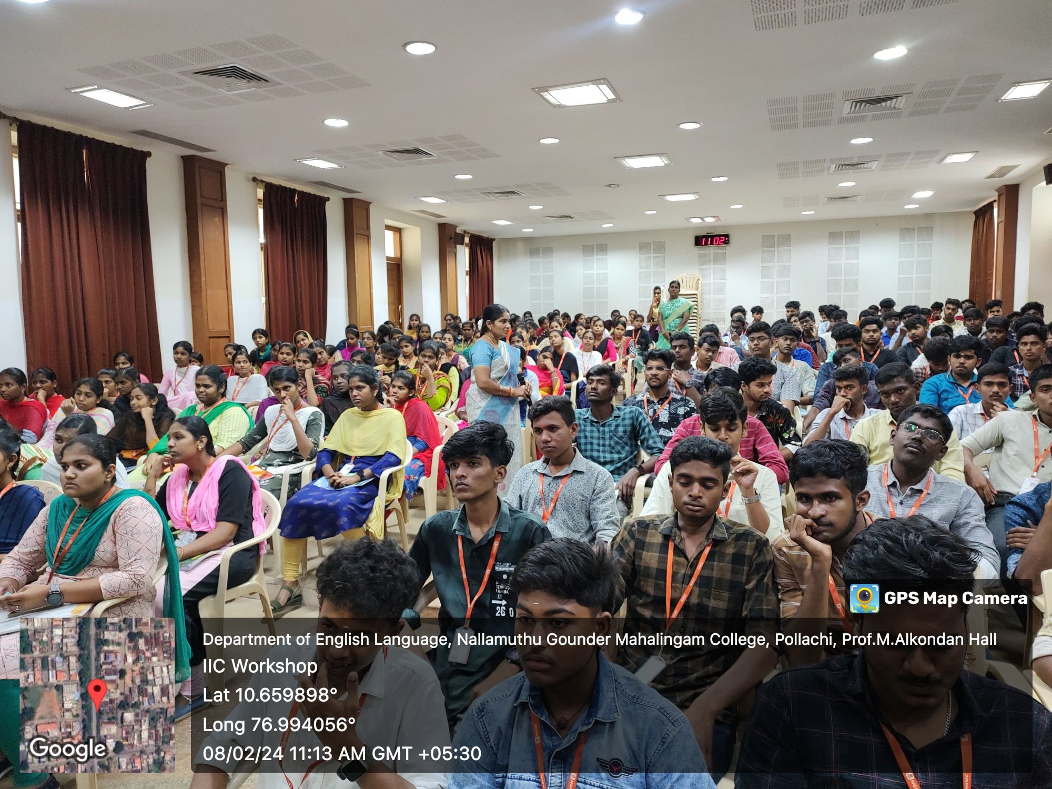

Session 2
Dr.V.Indhumathi
Associate Professor
Department of Mathematics

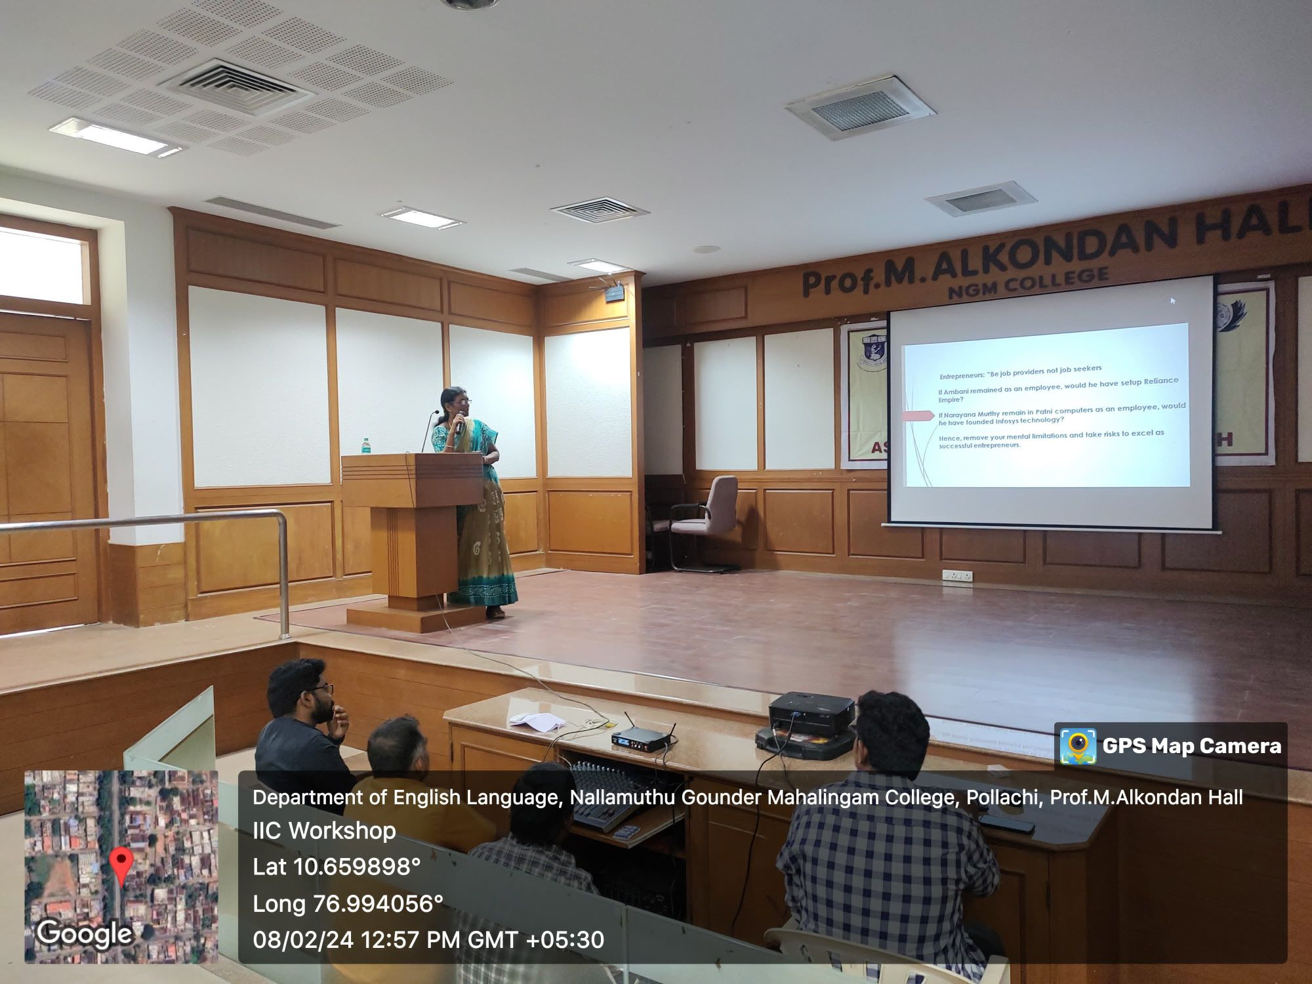

Session 3
Dr.V.Meera
Associate Professor
Department of Commerce
