- Nallamuthu Gounder Mahalingam College spreads across a extensive area of 26-acre campus designed with a focus on ambiance and serenity, complemented by the requisite infrastructure and abundant physical utilities for comprehensive teaching and learning process
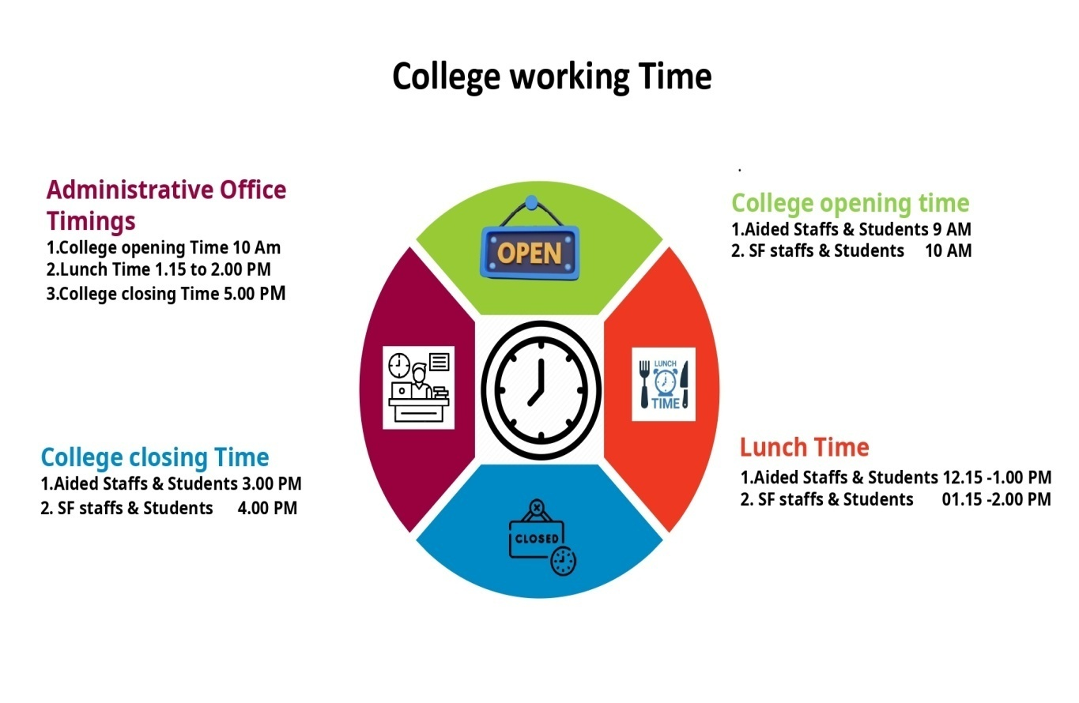

- The campus consists of 120 spacious, furnished, and well-ventilated classrooms. There a is pre incubation centre in campus where students can utilize it for their startups
- The campus offers 200Mbps, 24/7 Wi-Fi connectivity through campus-wide variousaccess points. A firewall Sonic Wall 2700 is installed.
- ERP System has been implemented for admission, teaching-learning, examination and administrationrelated activities
- The College has 950 computers, 14 smart boards, 44 LCD projectors and an e-studio for creating and sharing teaching resources.
- The college has 20 modern laboratories
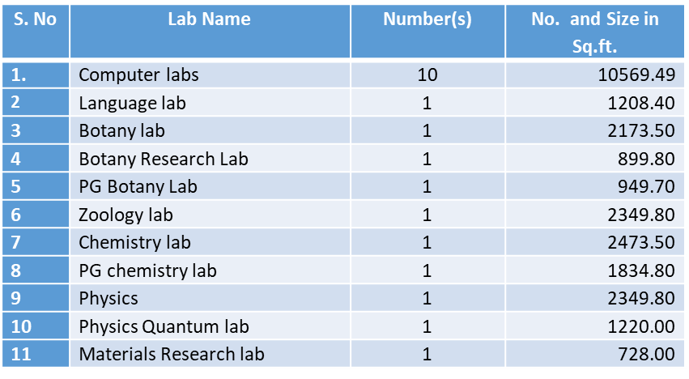
- Science laboratories for Botany, Chemistry, Physics, and Zoology are equipped with DST-FIST funded instruments worth about 22 lakhs.
- The College has 1 Auditoriumand 5 Seminar Halls with varying seating capacities.
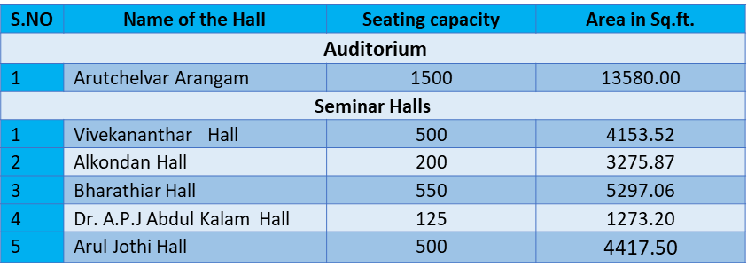
Library Facilities:
The library has been equipped with a fully automated Integrated Library Management System (ILMS) and can accommodate 250 users.
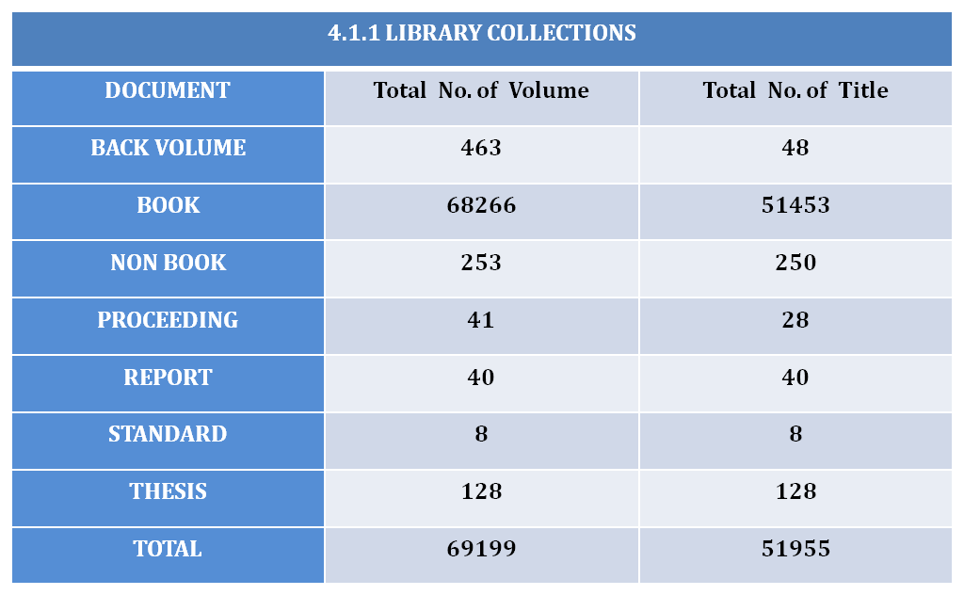
Cultural Facilities:
Students cultural teams are formed and trained to participate in the competitions held outside the campus and won the prizes. The college's Fine Arts club aims to uplift student cultural talents. The Auditorium and 4 Seminar Halls are available toconduct all the functions and events. Student-managed 15+ Clubs and Societies encompass various areas such as Arts, Technical, Societal and Business, aimed at enhancing curricular learning through extracurricular activities.
Yoga:
The Department of Human Excellence has been enhanced and established with a faculty strength of 11 members, and the course has been extended to all undergraduate (UG) students. The curriculum describes the learning goals and outcomes of the academic program. As part of the curriculum (Part IV), Yoga is a mandatory component. The department provides spacious facilities, including the Arul Jothi Hall (4417.50Sq.ft.), two yoga halls (1053.00Sq.ft.), a meditation room, Jothi Nilayam and a Yoga center. Experienced teachers guide the students in various activities such as meditation, self-reflection, yoga, and Kayakalpa exercises. The department operates the NGM Yoga Therapy Centre, which caters to the needs of Public, students, faculty and the wider community.
Sports and Games:
The college dedicates a spacious area in the campus to sports and indoor & outdoor games, recognizing the importance of health and physical fitness. The Physical Education Director and assistants, train the students in both indoor and outdoor games and athletic events. The sports facilities are used for inter-collegiate, inter-school and intra-university tournaments and games. Every year NGM organize intra university tournaments with the support of management.
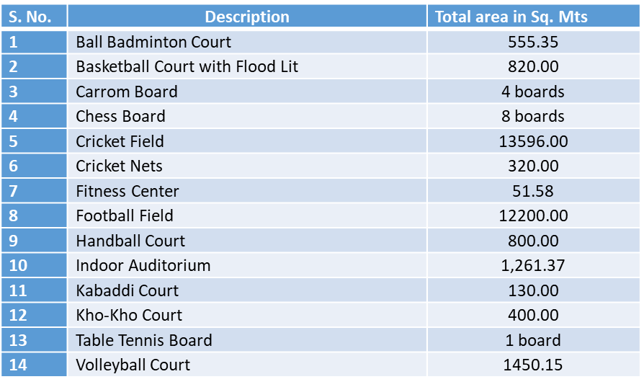
The college provides a fully equipped multi-gymnasium for boys and girls. Boys can access it from 6 am to 7 am and 4.15 pm to 5.15 pm, while girls have access from 7 am to 8 am and 3.15 pm to 4.15 pm. The gym is under the preview of Physical Director.
The following equipment’s are present in the gymnasium
